Illustrated steps for creating a Naturalliance-satellite
1. Log-in to https://www.sycl.net/editor/login.aspx with your email address as user-name.
If you have one site, you should land on a “Site Settings” page like the one below. If there is a table of sites, double-click in the “Site title” box for the one you want.
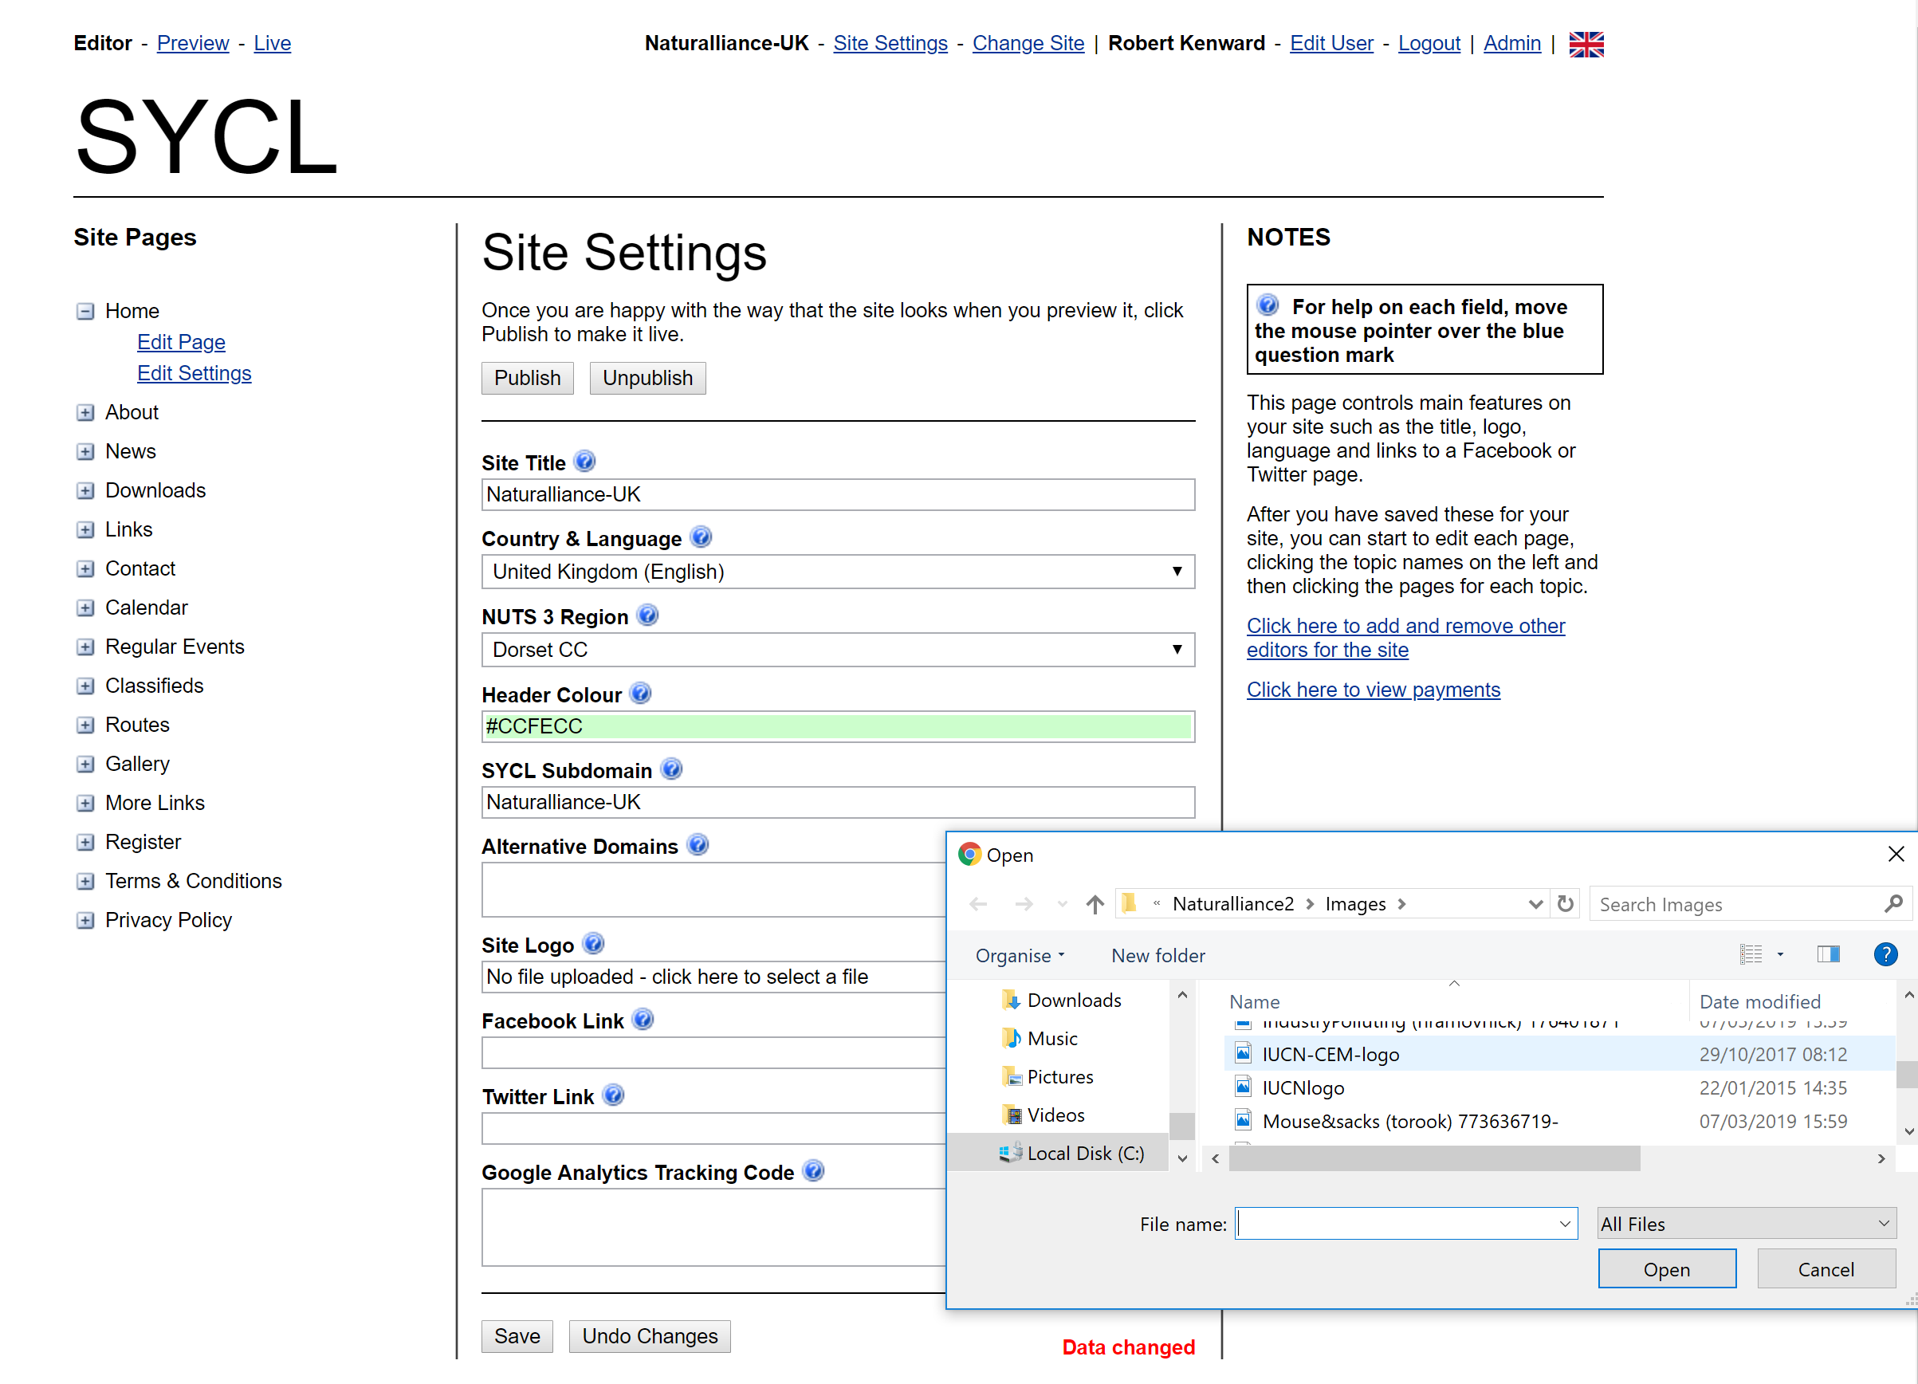

Visit https://sume.sycl.net/4/documents and in the ‘Satellite Creation’ section download the ‘Satellite Logo (IUCN-CEM)’, the ‘Satellite Home Page image’ and the ‘Satellite Covid image’.
Click on the box “Site Logo” (in the green ellipse). A dialogue box opens. Select the IUCN CEM logo which you downloaded and double-click on it (or Click on Open) to upload it.
Remember to save your work by clicking SAVE at the bottom of the page!
2. Click on <Home><Edit Page> in the left menu (see red ellipse in image above)
In the box “Link Position” (in the red ellipse below), choose ‘Left Menu’.
In the box “Page Title”, write “Our nature” (translated if appropriate)
Click in the box “Page image” and upload the ‘Satellite Home Page image’ which you downloaded.
In the box “Image width” set it to Full Column Width.
Into the box “Image text”, copy (or translate) the legend in Appendix 1 at end of these instructions.
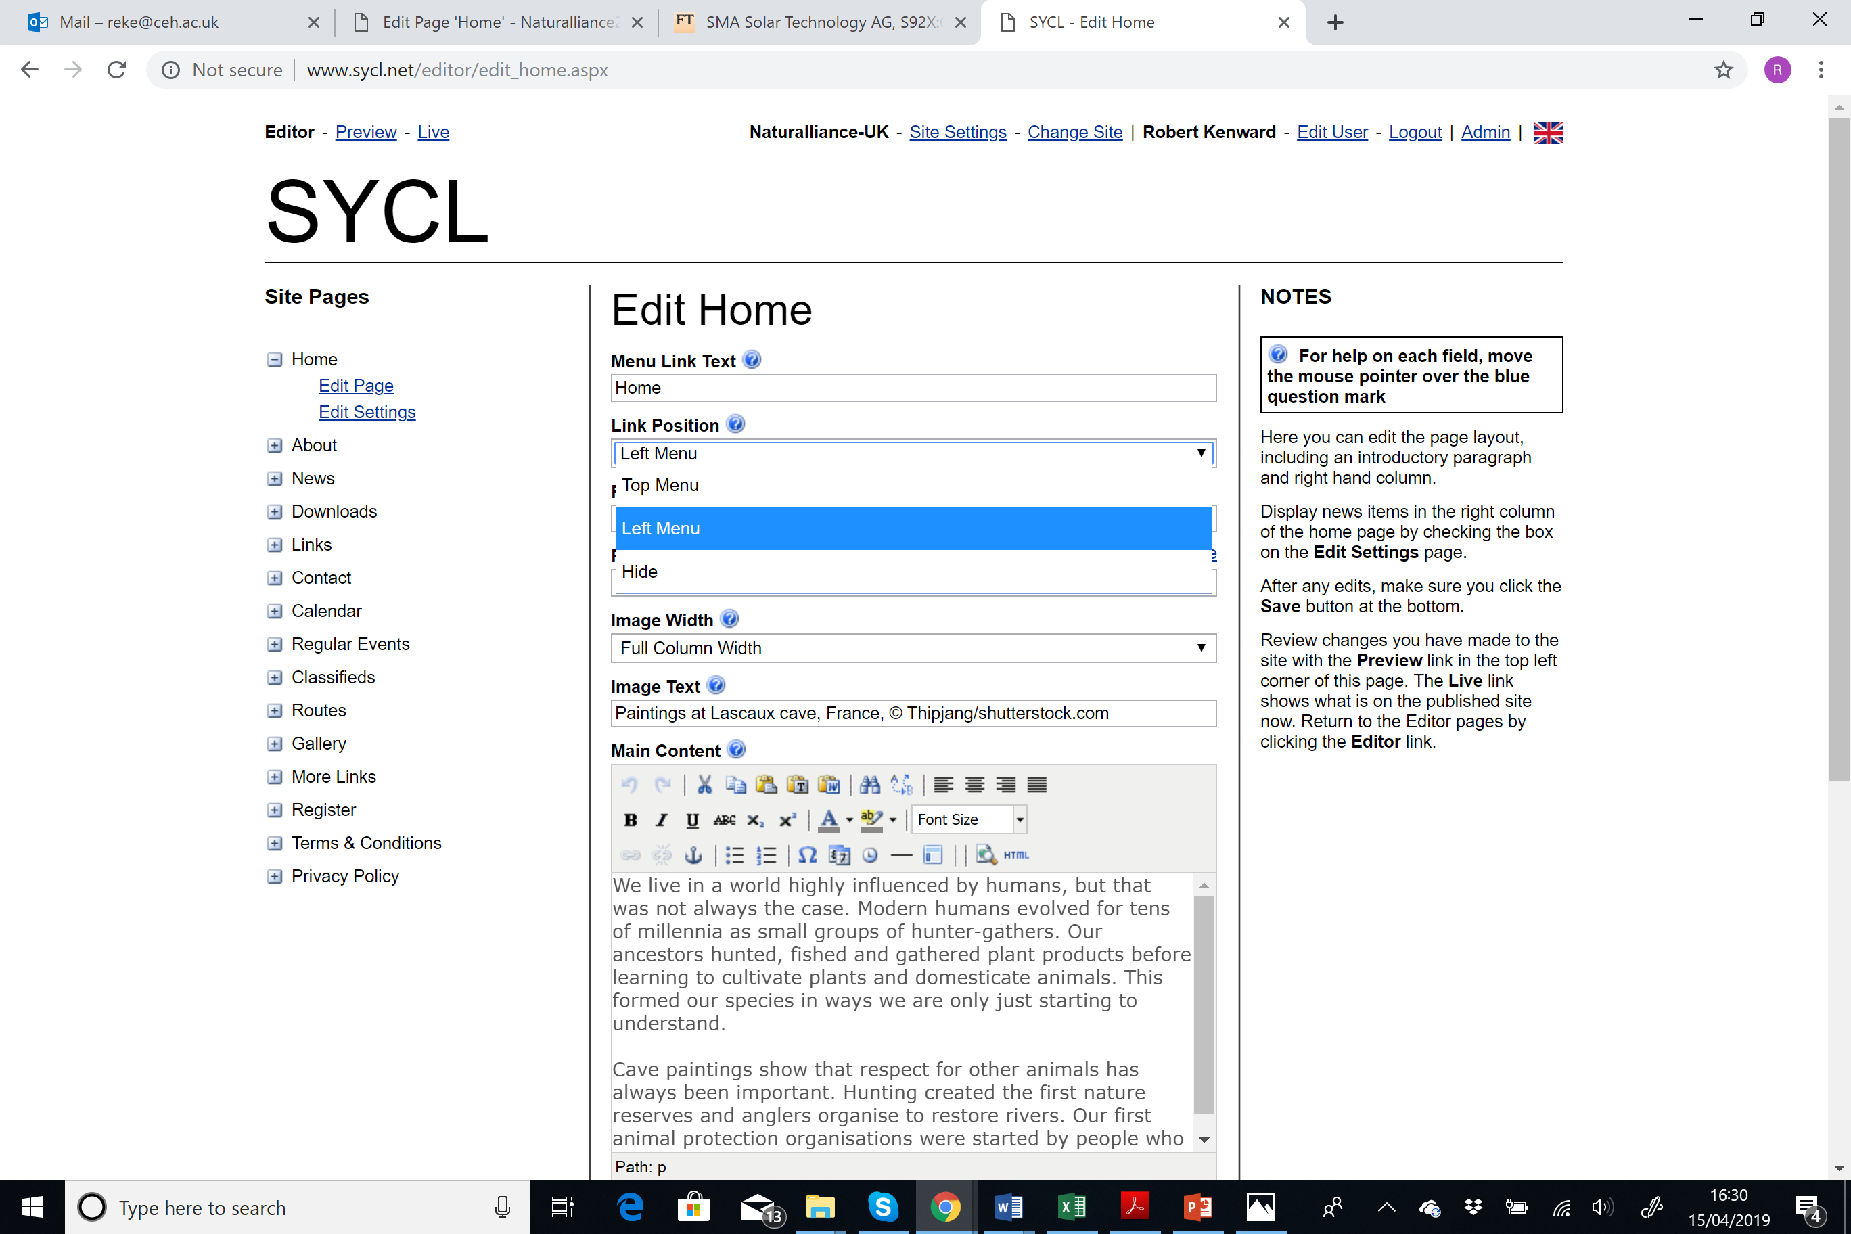
In the box “Main Content”, copy/translate the text (one paragraph) in Appendix 1 at the end of these instructions. The “Right content” text (four paragraphs) is also shown there.
Remember to save your work by clicking SAVE at the bottom of the page!
Most links in these texts are for networking back to the hub. The ones given in these instructions are for the UK and need to be updated with ones for your language and your area. The first is to the About page on http://www.naturalliance.org. Click the link to open that page in a new window, select your area from the language menu (globe at top) and copy that link (in dark blue ring below).
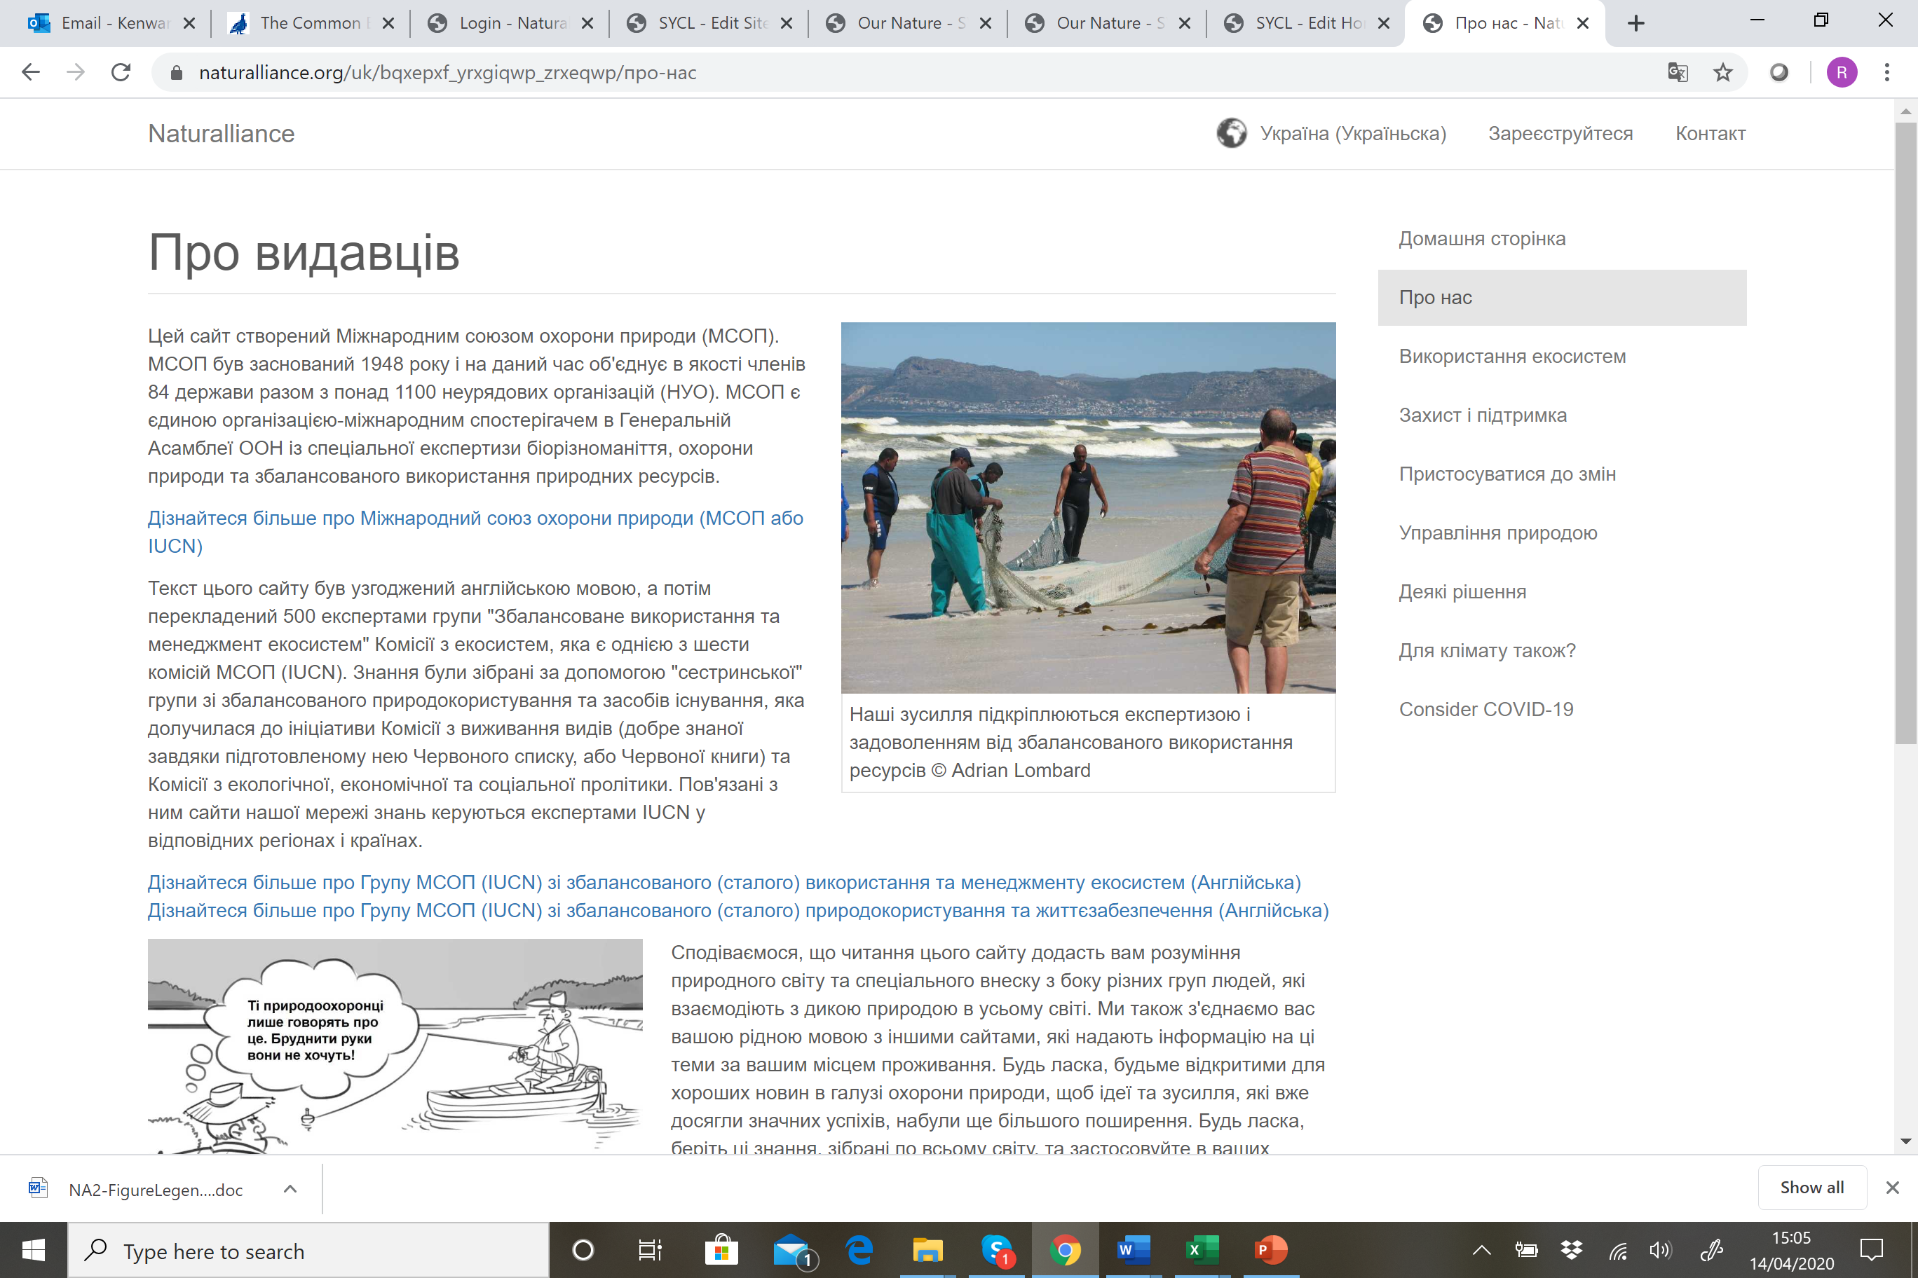
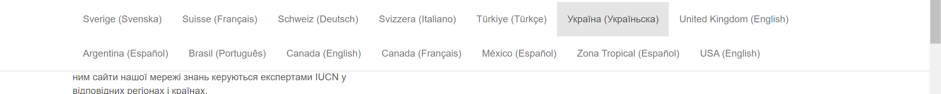
Then, come back to the SYCL editor. Select the text you want to “link” (red ring) with your cursor, and click on the link symbol (green ring). An ‘Insert/Edit Link’ Box opens. In the “link URL” box, delete all the “old” link and copy and paste the new link URL. Then press “Update”. If you paste from Word into the HTML editor (you may need to use the blue-ringed Paste from Word button) it remembers links.
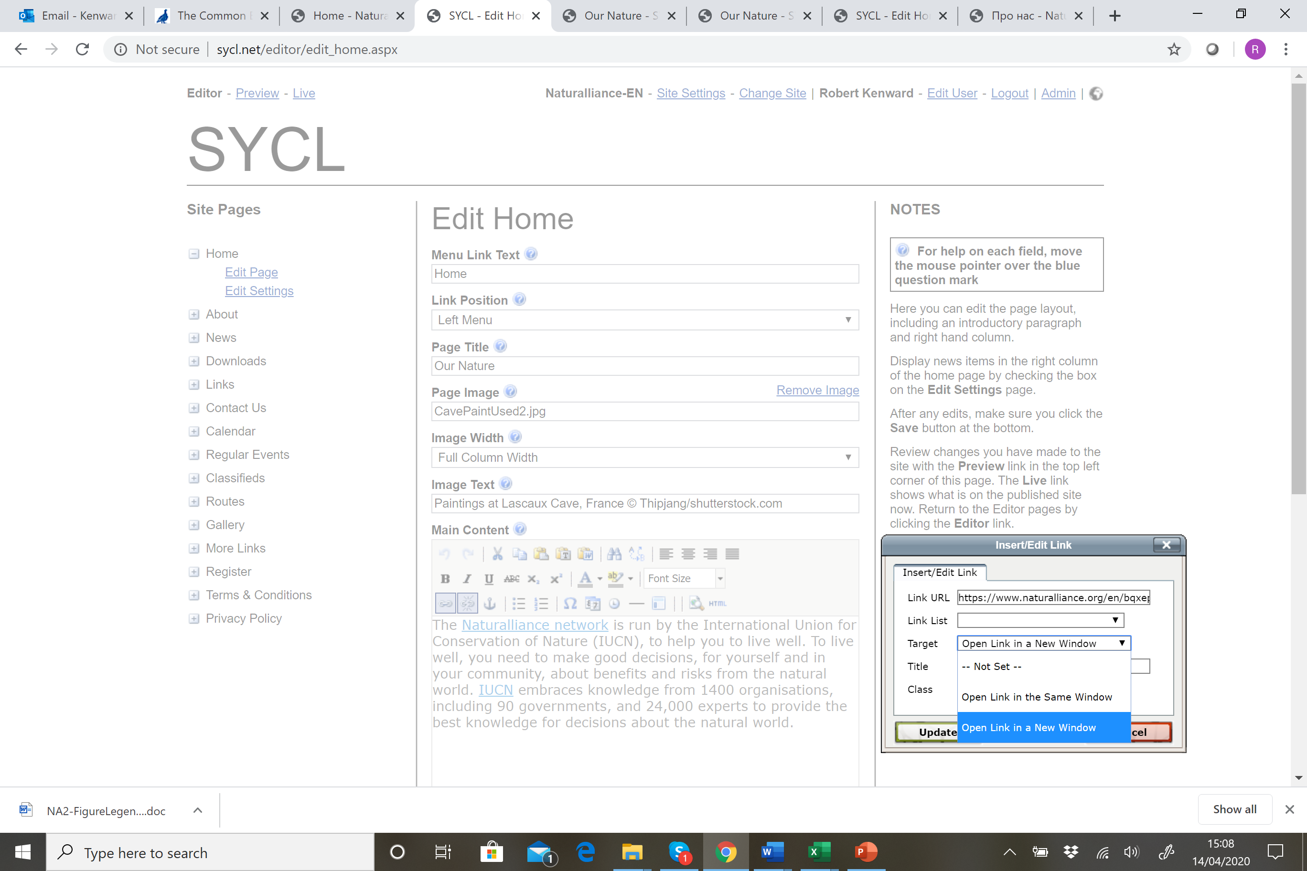
Repeat the process for the links in the Right Column text. The first there (‘we all depend on nature’) should link to the Home Page in your area. The second link ‘to manage nature well’ goes to the page on Natural Governance (page 6), the third to the page on COVID-19, the fourth to the page on Climate Change and the last, on ‘nature itself’, to the Some Solutions page. Don’t forget to SAVE!

3. To tidy your site, go to each Site Page (by clicking on each items of the list in the left menu then on “edit page”)
In the ‘Link Position’ box, set: - ‘Top Menu’ for “Terms & Conditions” and “Privacy Policy”;
- ‘Left Menu’ for “About” and “Contact Us”;
- ‘Hide’ for all the other pages.
Don’t forget to SAVE!
4. Click on <About> and <Edit Page>
For Menu Link Text, insert/translate “Avoid Covid-19”; the Page Title is “How to avoid Covid-19”;
- Insert the image AvoidCovid and set Image Width to Full Column Width (see last page: Appendix);
- Image Text is ‘Advice for avoiding Covid-19, by Chris Heward from Japanese government concepts’
Don’t forget to SAVE!

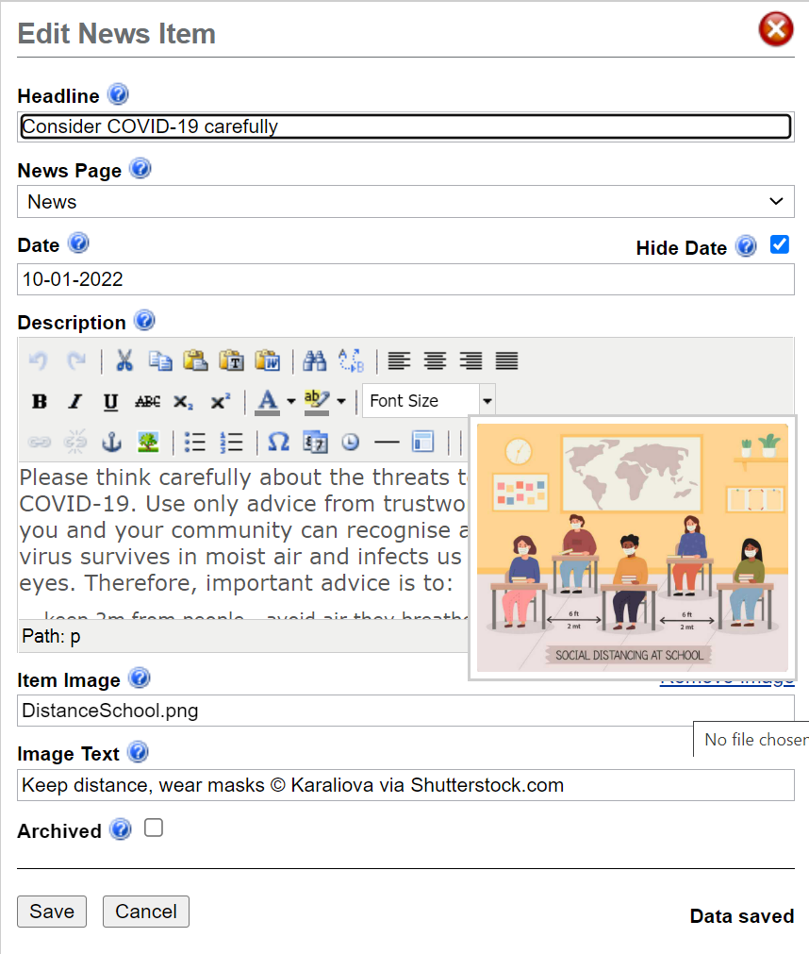
5. Click on <News ><Edit Items>
Click on<Create> to get the dialogue box as shown on the right.
In “Headline” box, copy/translate “Consider COVID-19 carefully”
Ignore the “Date” box; some news items do not need dates.
In the box “Description” copy and translate the text shown at the end of these instructions (with the links). You need to modify the last link, to the Natural Governance page, for your language and area. Other links need not change yet, but can you link a useful site of your government?
In the box “Items Image”, upload “Satellite Covid image”.
In the box “Image Text” copy (translate) “Keep distance, wear masks © Karaliova via Shutterstock.com”
Remember to click SAVE at the bottom of the page!
6. Click on <Home><Edit Settings> in the left menu
In the box “Show News Summary”, select “Centre Column” (see below)
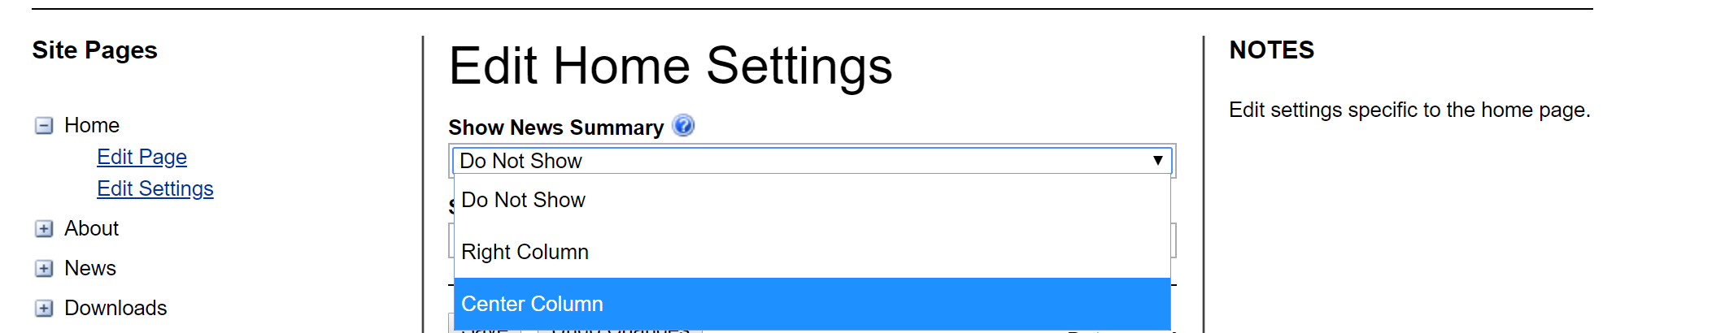

7. Next, use the Preview link at top left of the site to see how your work looks. Compare it with http://naturalliance-en.sycl.net/1/our-nature. Add lines or changing font size until the whole is nicely balanced visually, before reporting ‘Ready to Publish’.
To improve the process for the future, we’ll be asking you how long this took you!
‘Consider COVID-19 carefully’ is actually a News Item inserted on the Home Page. The idea of having News on the front page is extended as a simple blog at http://naturalliance-UK.sycl.net, with original Home page content copy-pasted to the About page, which is set to show on the ‘Left Menu’. A longer train of news shows also on a ‘News’ page at http://esug.sycl.net. Ideas on Naturalliance-UK may help to create your own pages, with links to the hub for themes on conservation through sustainable use. Later, we will show how PDFs can be linked into text as ‘extra pages’ and how to set up a list for mail-shots. There are more content management examples at http://sycl-uk.cycl.net.
APPENDIX 1: Text content for satellites

Image legend: Paintings at Lascaux cave, France, ©Thipjang/shutterstock.com

Centre Column content [you will need to update this link to the hub for your area]

The Naturalliance network is run by the International Union for Conservation of Nature (IUCN), to help you to live well. To live well, you need to make good decisions, for yourself and in your community, about benefits and risks from the natural world. IUCN embraces knowledge from 1,400 organisations, including 90 governments, and 24,000 experts to provide the best knowledge for decisions about the natural world.

Right Column content [you will need to update these five links to the hub for your area]

We live in a world highly influenced by humans, but that was not always the case. Modern humans evolved for tens of millennia as small groups of hunter-gatherers. Our ancestors hunted, fished and gathered plant products before learning to cultivate plants and tame animals. This formed our species in ways we do not fully understand.

Cave paintings show that respect for other animals has always been important. Hunting created the first nature reserves and anglers organise to restore rivers. Animal protection organisations were started by people who had gained empathy for companion animals.

Nowadays, humans dominate and harm nature’s riches. Yet we all depend on nature for air to breath, clean water, and clement weather to grow crops. Many of us stay healthy through recreation in nature. We should learn ways to manage nature well, not least for COVID-19 and wildlife trade. If you enjoy wild foods or just love watching wildlife, you too can help conserve those resources.

Hunters and watchers of wildlife do not always cooperate, but they need to. Conflicts divert attention from threats to all, like climate change. Using renewable resources sustainably is not different from using farmed produce, but often better for conserving nature. Hunting, farming and other uses of natural resources can be solutions for conservation and the threats from global warming. We need to focus together on solutions, based both on technology that creates new livelihoods and on nature itself.

News Item content: Consider COVID-19 carefully [you need only update the final link]
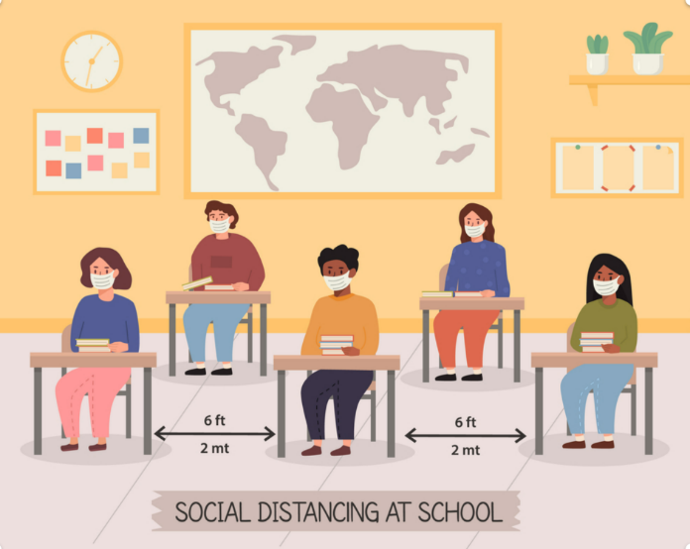
Please think carefully about the threats to you and nature from COVID-19. Use only advice from trustworthy organisations on how you and your community can recognise and avoid this disease. The virus survives in moist air and infects us through mouth, nose and eyes. Therefore, important advice is to:
- keep 2m from people - avoid air they breathe out;
- wear a mask when surrounded by many people in enclosed environments or crowds;
- obey rules about travel and get vaccinated if you can;
Keep distance, wear masks © Karaliova via Shutterstock.com

Measures against future pandemics must also be devised wisely, based on the best science. New laws should avoid harm to rural livelihoods and to nature conservation.
APPENDIX 2. COVID-19 diagram.
1. Here is how to add the diagram to help people avoid Covid-19. At https://sume.sycl.net/4/documents in ‘Satellite Creation’, the last link downloads a Powerpoint containing one slide. The slide needs to have labels translated, then to be uploaded as an image.
2. Open the Powerpoint file and translate all the text of each image. Then left-click on the outer frame of the image until you get the Menu shown below, and select ‘Save as Picture’. Save the slide as AvoidCovid.jpg. (Ignore the depiction of a second slide on the left on the image below)
