Constructing the Naturalliance-satellite Home Page using the “Our Nature” text below
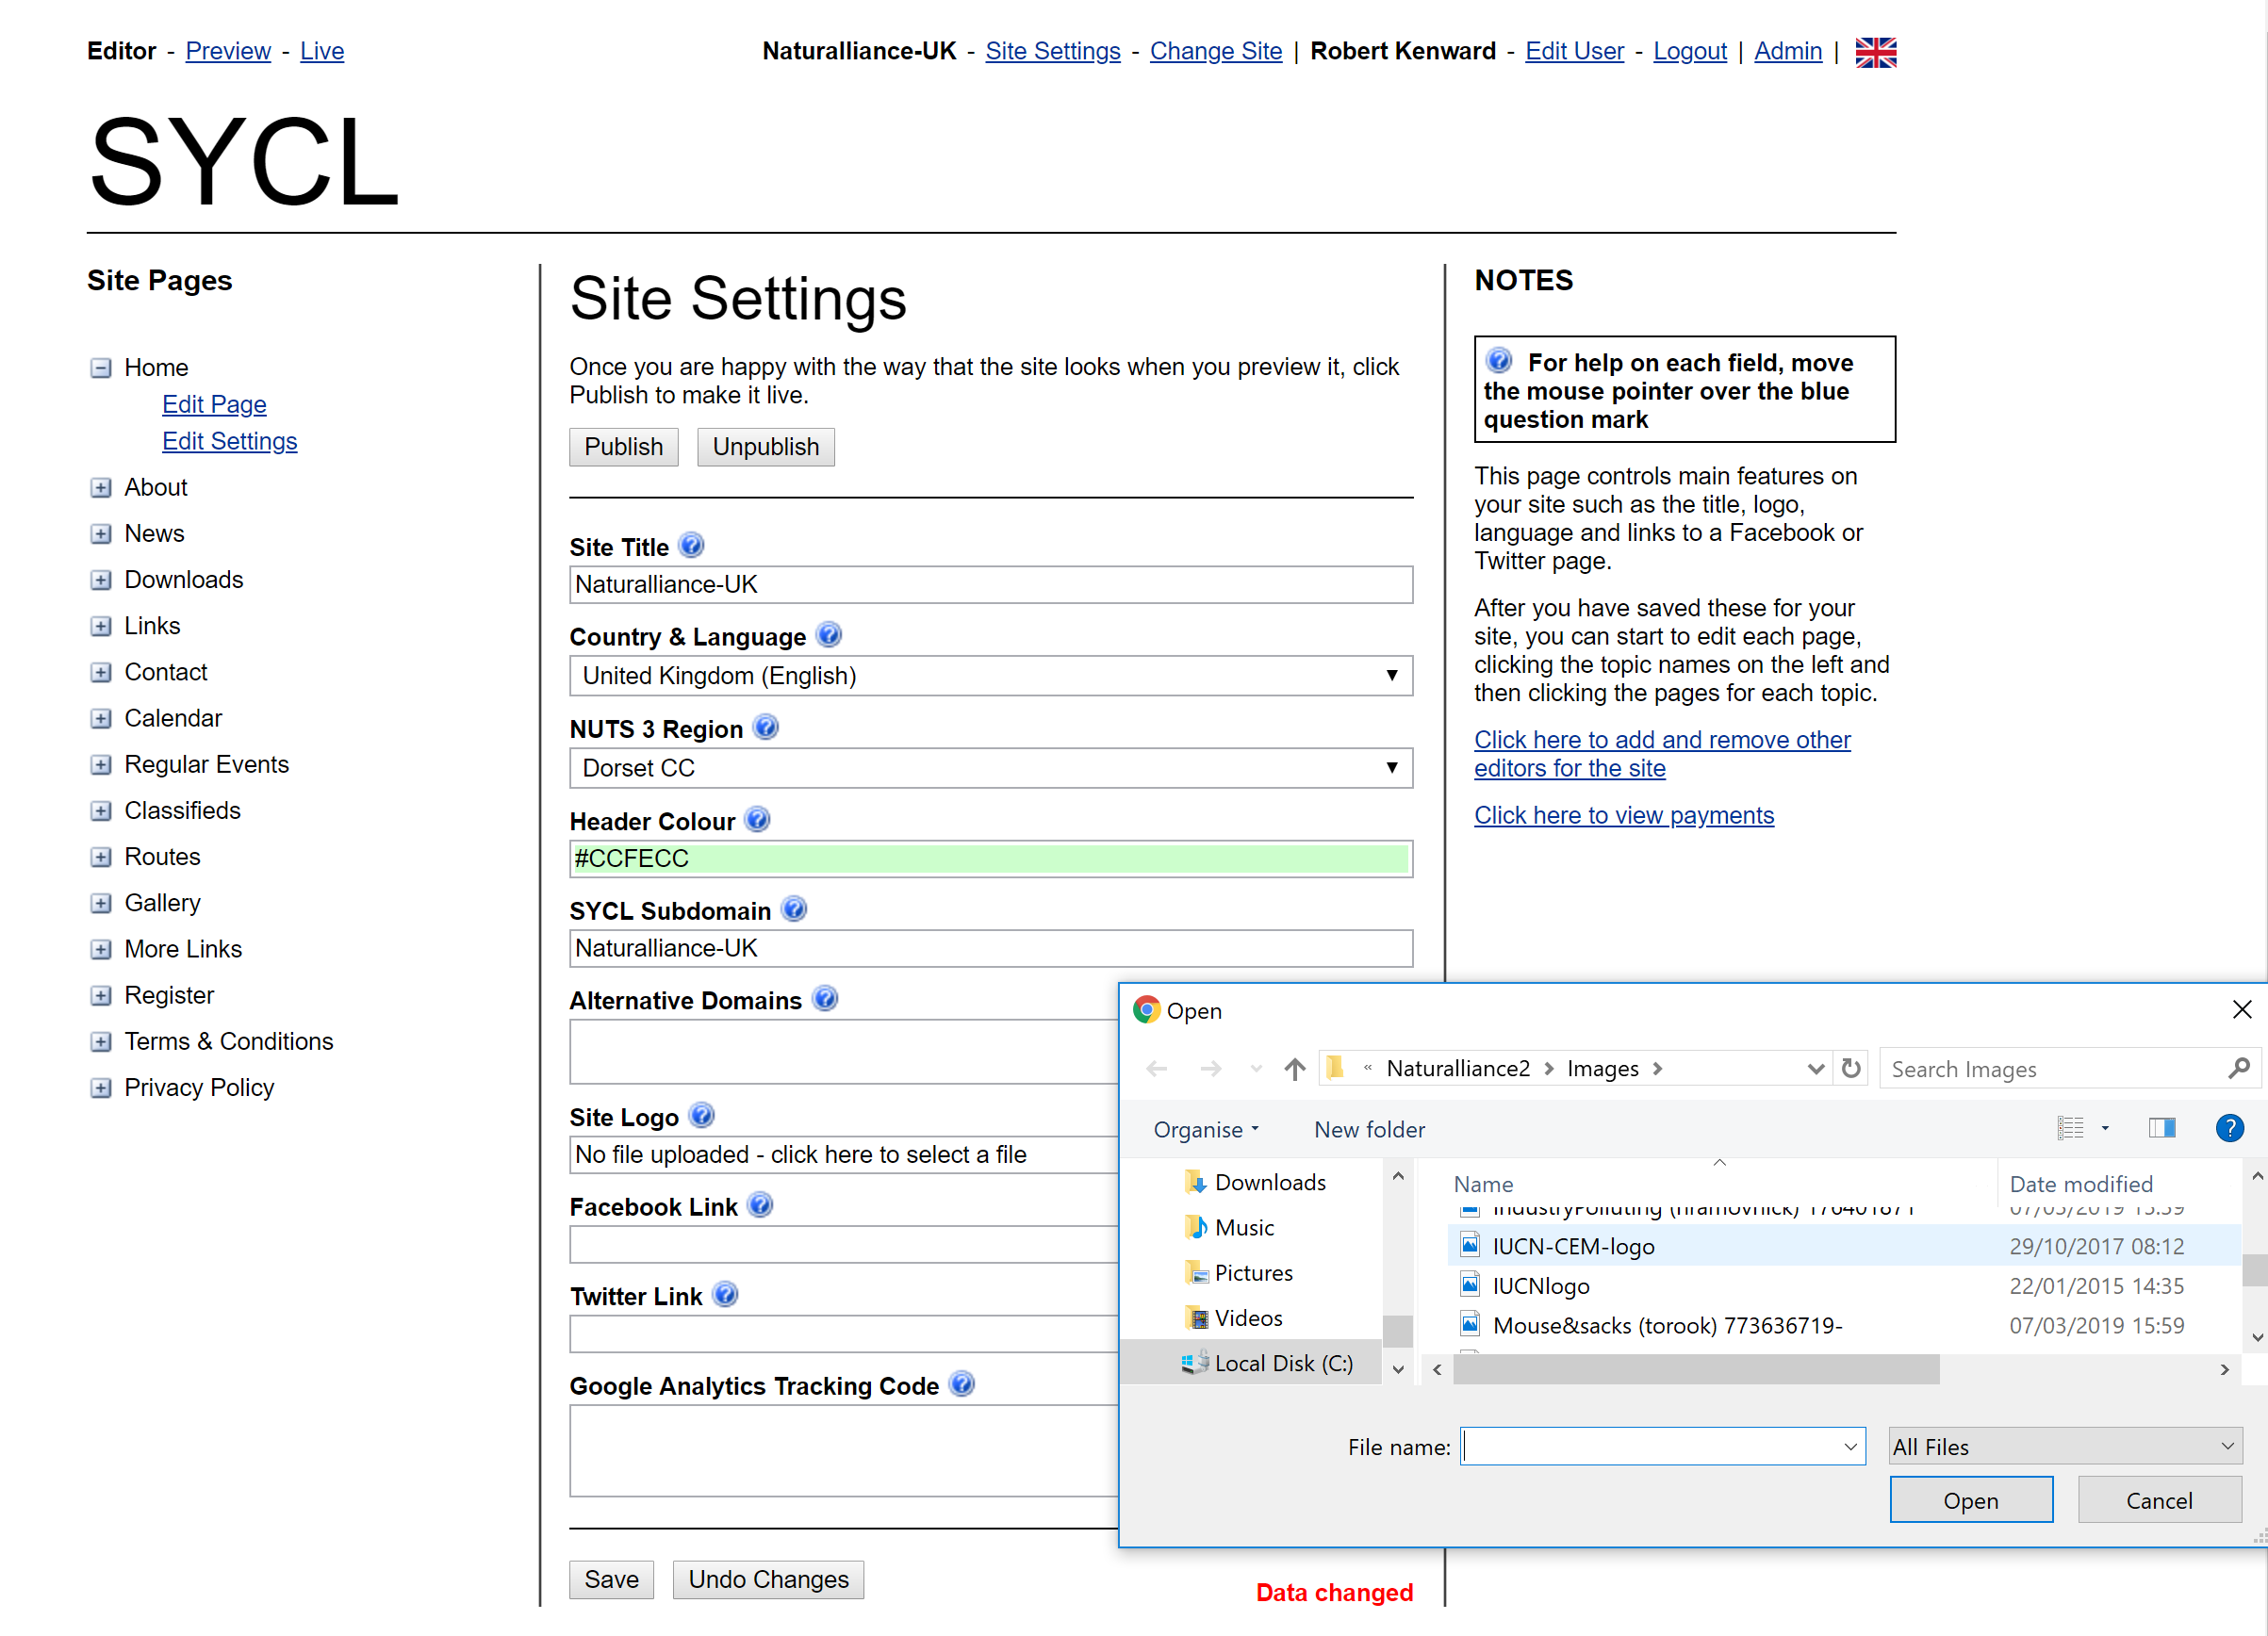
1. Log-in to https://www.sycl.net/editor/login.aspx. with your email address as user-name.
If you have one site, you should land on a “Site Settings” page like the one below. If there is a table of sites, double-click in the “Site title” box for the one you want.

2. While you are on this page, it is a good time to upload the IUCN-CEM logo for your site (down-load it here) . Click where the green ellipse is to get a dialogue box for that. Remember to use the <Save> button at the bottom! Then click on the left <Home><Edit Page> in the red ellipse.
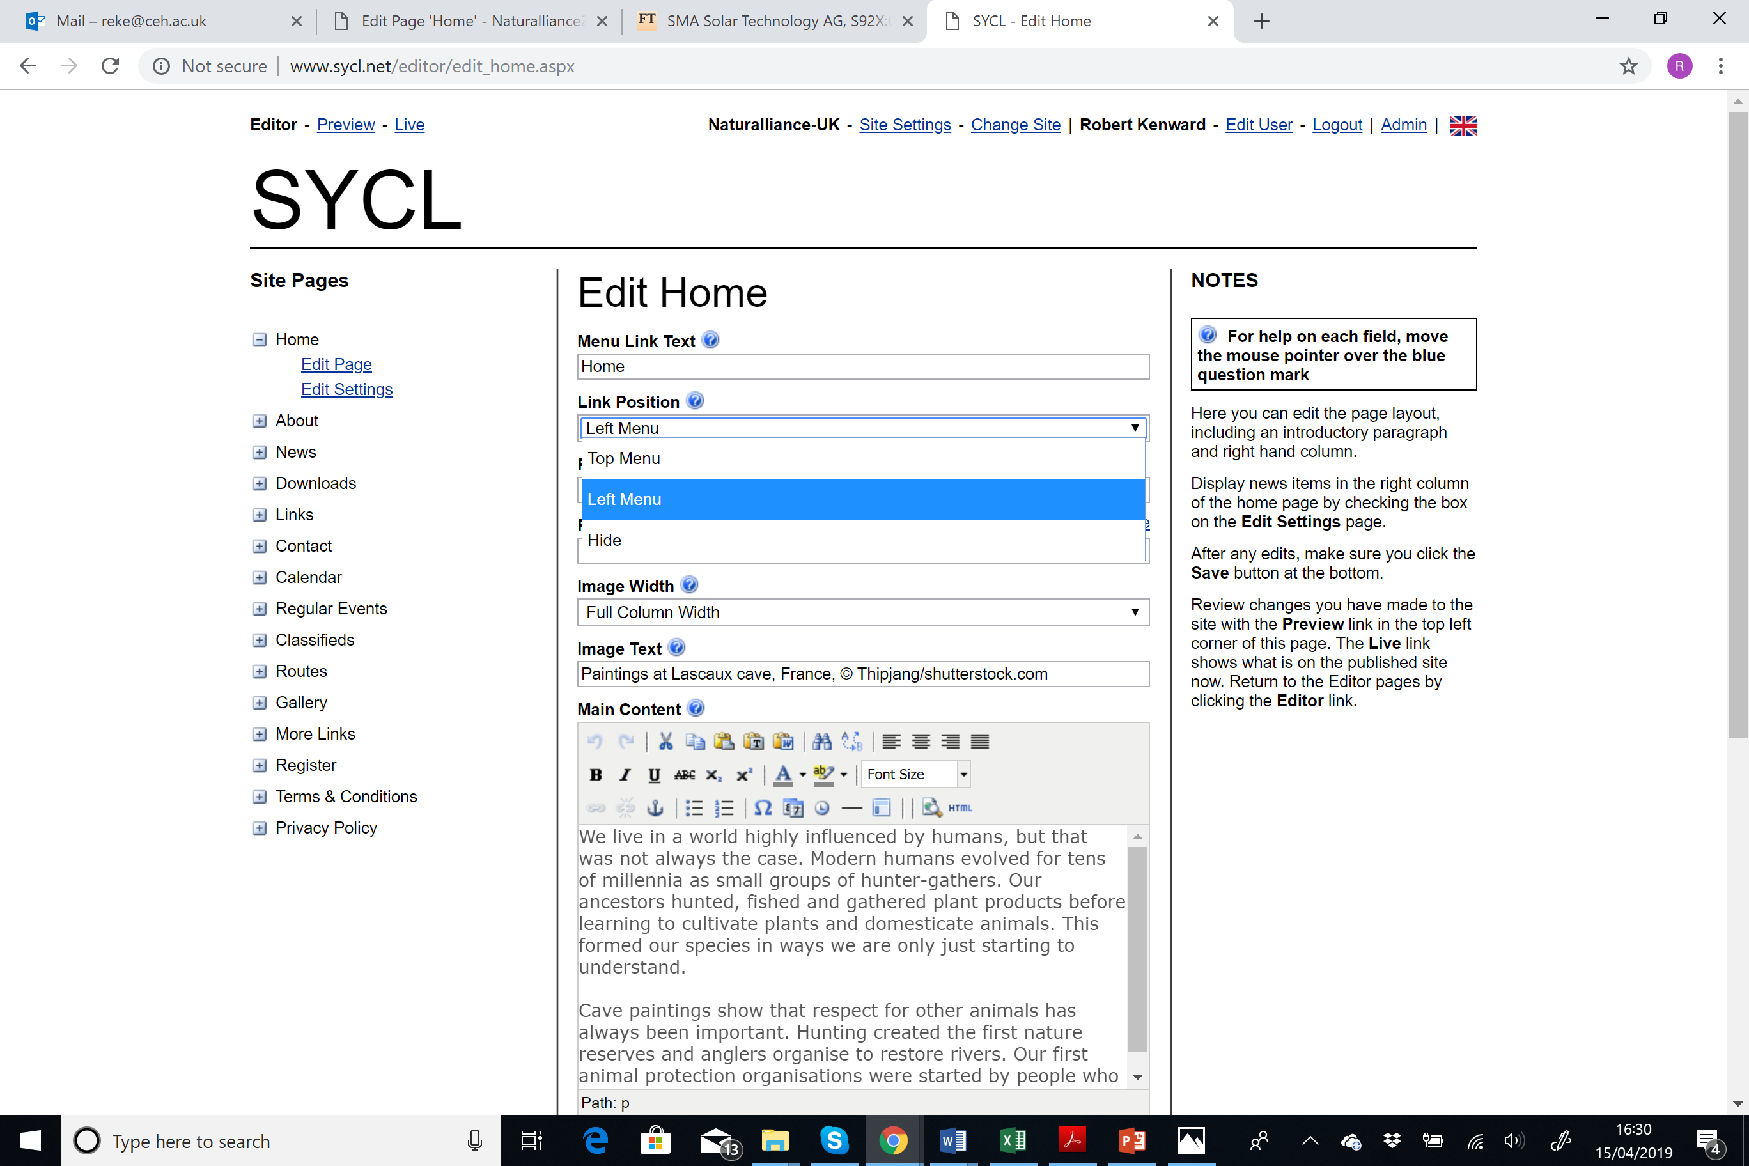
3. Download the image for the home page, then click the red circle to get the menu for the Home Page link, and set it to ‘Left Menu’. Next, enter “Our Nature” (translated) in the ‘Page Title’ box and upload the picture for the page, set it full width, & translate “Paintings at Lascaux cave, France, ©Thipjang/shutterstock.com” in the ‘Image Text’ box.
4. It’s time now to add the Home Page text. Copy the first two paragraphs (show at the end of these Instructions) from the separate Word text into the ‘Main Content’ box, then do the same for the last two paragraphs into the ‘Right Content’ box. In order to paste in a way which ‘remembers’ the links, you may need to use the ‘Paste from Word’ icon (shown with a blue ring below) and right-click to paste into the new box, then <Insert>. It is wise to <Save> before working on the links.
5. When you paste from Word into the HTML editor, it remembers the links. However, the ones in the English text you are given below are for the UK. You need to edit the links to be right for your language and area. Put your cursor in the first (red-ringed) link and then click the green-ringed button to get the ‘Insert/Edit Link’ box.
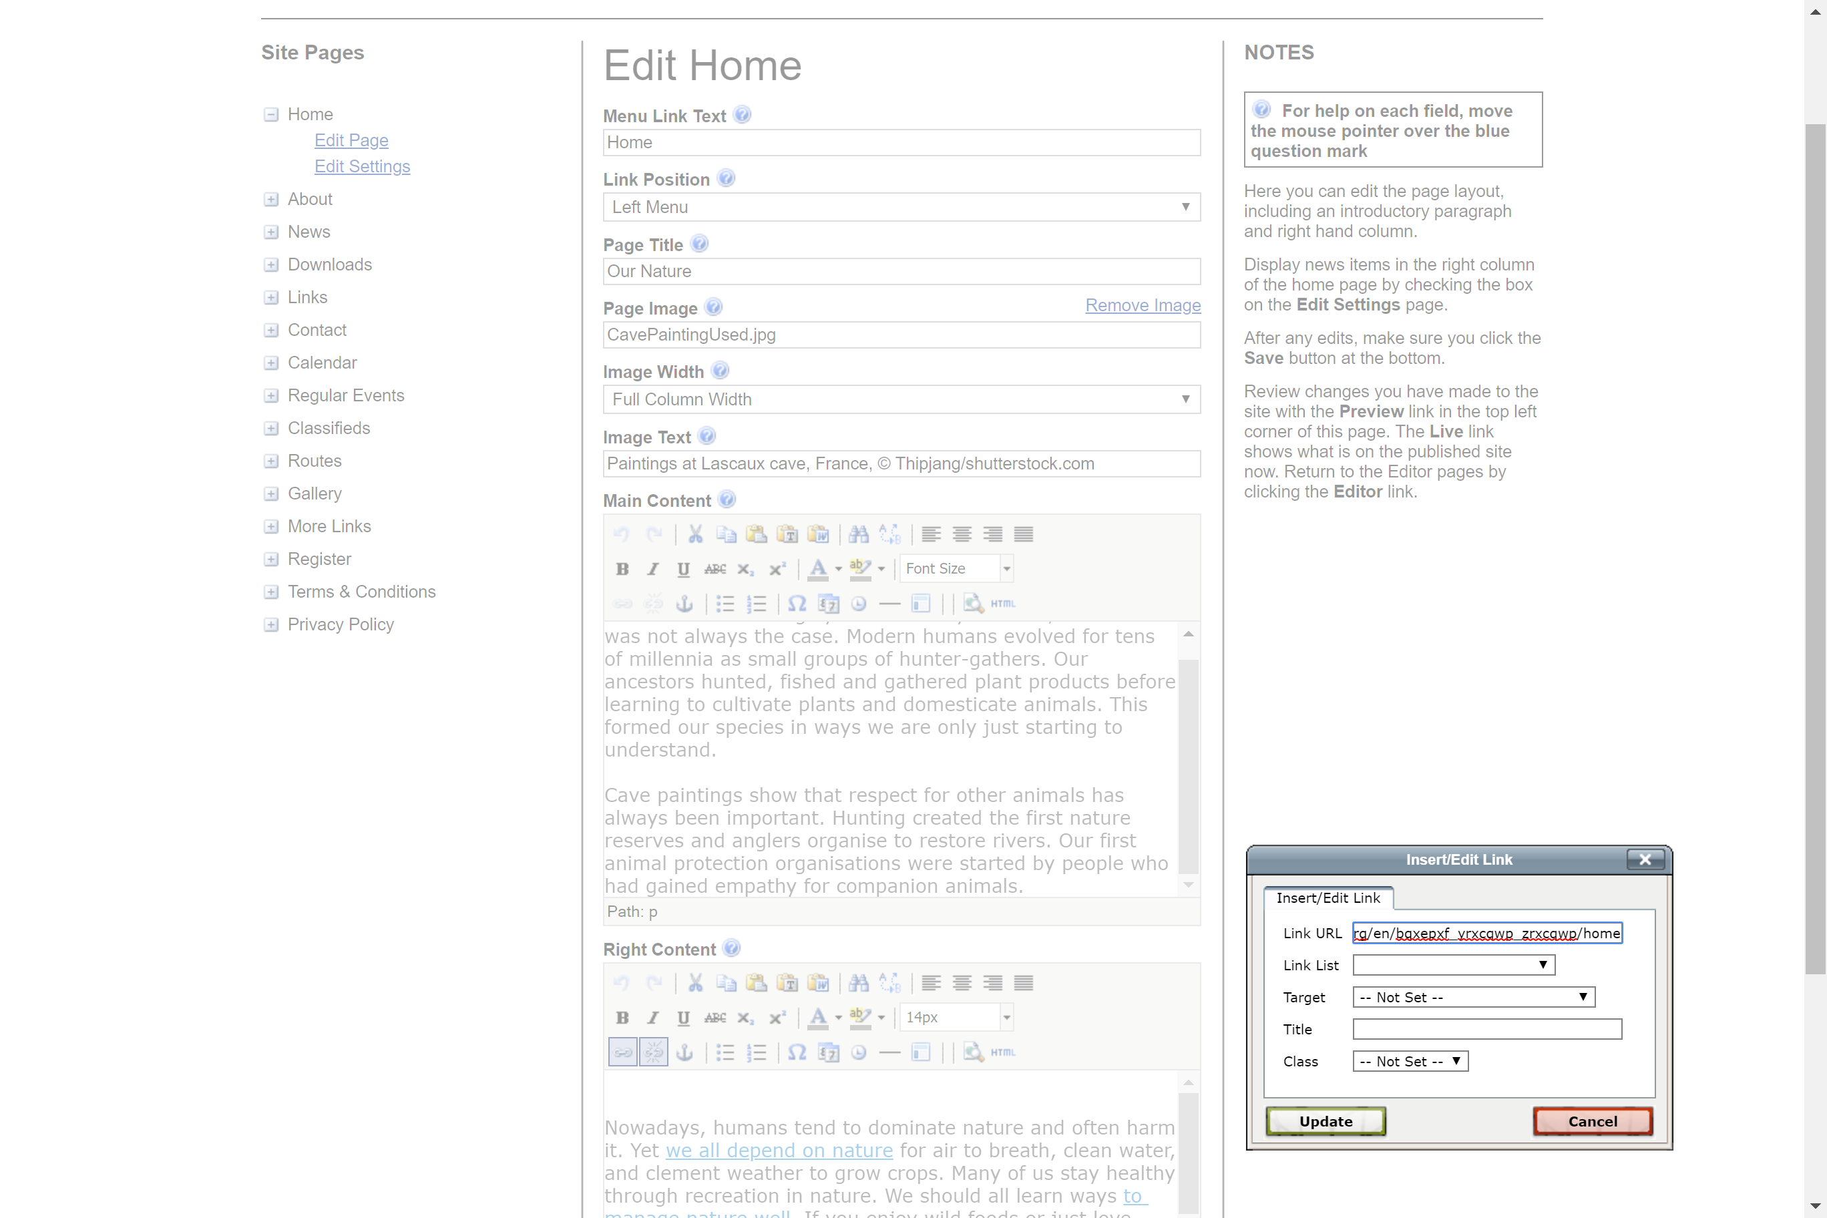
6. Now, go to http://www.naturalliance.org, select your country and area from the language menu (globe at top) and copy that link (blue in ring below). Go back to the ‘Insert/Edit Link’ box, delete the link there (be careful to delete it completely), paste in your link and press ‘Update’.
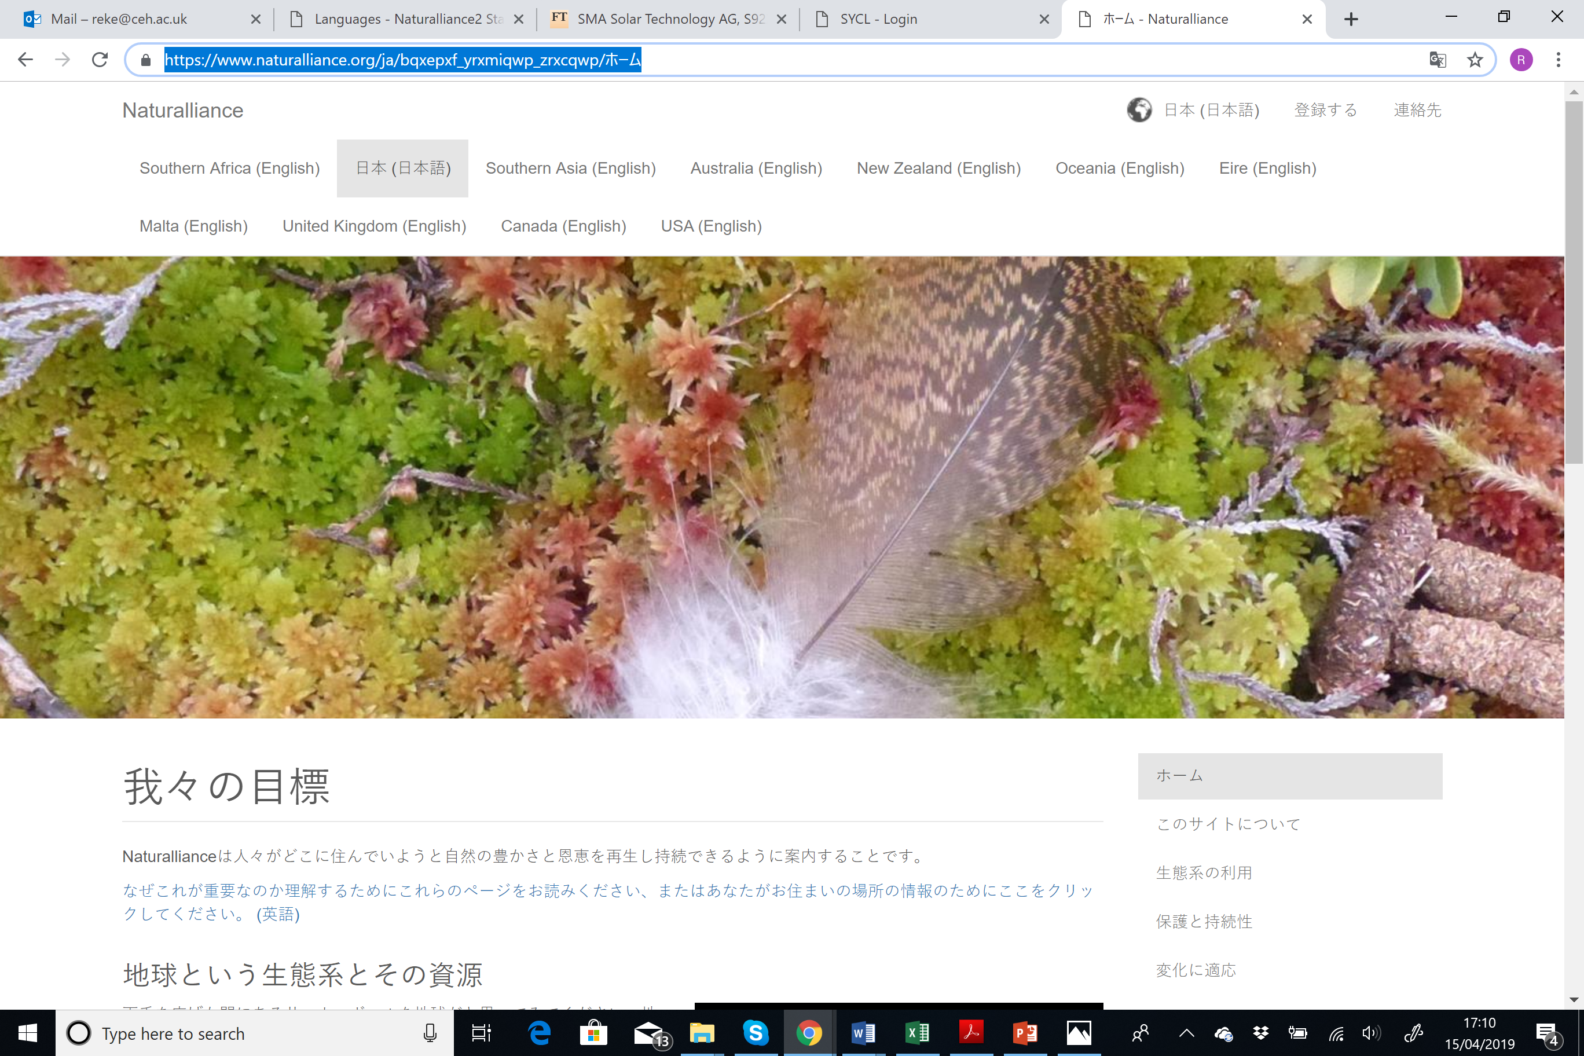
7. Do exactly the same for the next link (‘to manage nature well’), and link it to the hub page on Natural Governance (page 6) in your language. The third one is the last link (‘We run this network’) which links to the About page (p. 2) on the hub. Don’t touch the other links or forget to <Save>!
8. To finish the tidying of your site, go to each Site Page in turn and, on the ‘Link Position’ box (as at Step 3 above), set ‘Top Menu’ for “Terms & Conditions” and “Privacy Policy” , ‘Left Menu’ for “Contact Us”, and ‘Hide’ for all the others (for now), checking translation in the Menu Link Box at top.
9. Finally, use the Preview link at top left to see how your work looks, adding lines or changing font size until the whole is nicely balanced visually, before going to Site Settings (top) to <Publish>.
[Below is the text for this simple satellite site. Please translate it to the language you require, and set the links to the pages for that language on the hub as described at 5-7 above. For the links on “government, hunting and birds-watching”, click within each link, translate the word, and then carefully delete the English letters before and after your translation without losing the link.]

Our Nature
We live in a world highly influenced by humans, but that was not always the case. Modern humans evolved for tens of millennia as small groups of hunter-gathers. Our ancestors hunted, fished and gathered plant products before learning to cultivate plants and domesticate animals. This formed our species in ways we are only just starting to understand.
Cave paintings show that respect for other animals has always been important. Hunting created the first nature reserves and anglers organise to restore rivers. Our first animal protection organisations were started by people who had gained empathy for companion animals.
Nowadays, humans tend to dominate nature and often harm it. Yet we all depend on nature for air to breath, clean water, and clement weather to grow crops. Many of us stay healthy through recreation in nature. We should all learn ways to manage nature well. If you enjoy wild foods or just love watching wildlife, you too can help conserve those resources.
Hunters and watchers of wildlife do not always cooperate, but they need to. Conflicts divert attention from threats to all, like climate change. Using renewable resources sustainably is not different from using farmed produce, but better for conserving nature. Therefore, in 2004, an agreement to cooperate was signed in Europe between representatives of government, hunting and bird-watching. These groups are prominent among 1300 organisations in our International Union for Conservation of Nature, which represents nature conservation at the United Nations. We run this network to encourage conservation by all who benefit from wild living resources.

