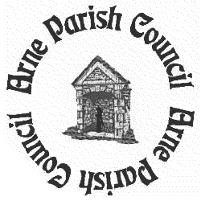

ARNE PARISH COUNCIL
NEWS

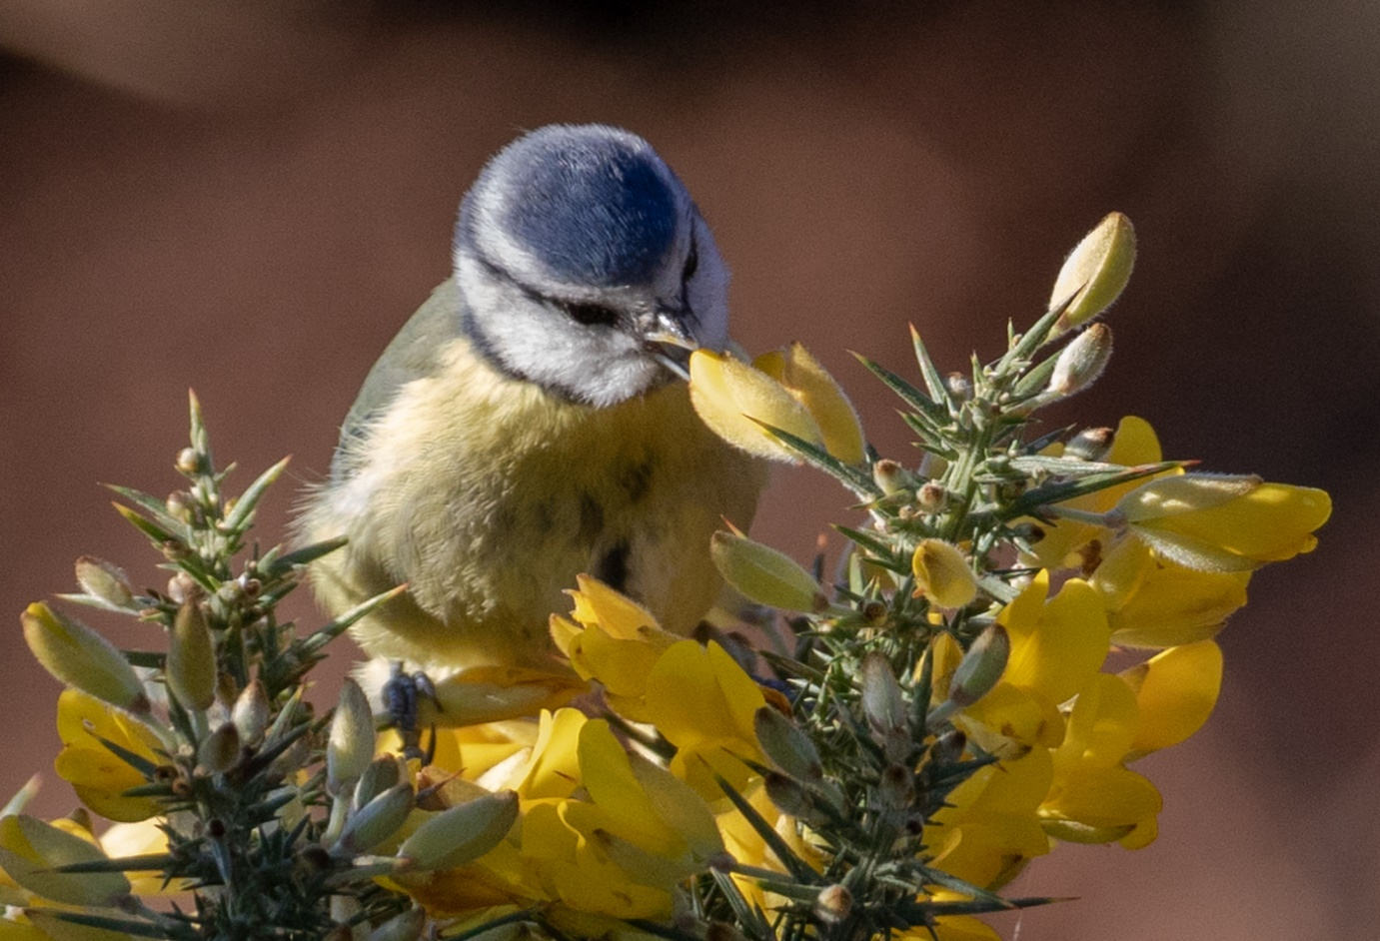

Cover photograph courtesy of Dr Gordon MacPherson

Editor’s Note

Welcome to the second edition of the Arne Parish Council Newsletter. It’s been three years since the last letter and, although it doesn’t seem like it, a great deal has happened during those three years. Parish Councillors have come and gone, and a list of the present councillors and their respective roles is included at the back of this newsletter. In March 2016 we sadly lost Caroline MacCleod. She was one of the first female Parish Councillors in this rural idyll and only the second female to be appointed Chair. She chaired with a sense of humour and a great deal of patience but with a rod of steel when required. Ray Scragg, the first editor of this Newsletter, stood down from the Parish Council at the beginning of 2018. Phil Love and Shelley Cranshaw took their places. In 2018, following a Community Governance Review, we were able to increase our numbers from seven to eight and Ian Church joined us in September 2018.

Report from the Chairman

It has been an interesting and challenging year for Arne Parish Council and, as the new Chairman, I have enjoyed the experience a great deal. We have been involved in many areas but I have picked out a few that we have worked on regularly:

- The Arne Moors Project: We have discussed this on several occasions with community representatives, both at our meetings and elsewhere. We are still investigating and are currently awaiting the final model and planning application.
- Neighbourhood Plan: The chairmanship of this group has recently changed but the steering group continues, and a draft is anticipated soon.
- Speeding: There is a genuine concern regarding speeding in the Parish. As a result, we have purchased a SID (speed indicator device) and have recruited a number of volunteers to undergo training enabling the SID’s position to be alternated between Corfe Road and Arne Road. We are currently awaiting the installation of the posts before this project can proceed.
- Lengthsman: We have appointed a lengthsman (a parish-contracted maintenance man) who is keeping busy tidying up and keeping vegetation at bay in various parts of the Parish.
- The Hayricks: This is being well used and we always carefully monitor the area to ensure the children are safe. However, we are concerned that some dogs are not being kept under control, as requested.
- Allotments: These are being well looked after by the holders who keep them tidy and productive. If anyone would like one, please contact the Clerk.
- Election of Parish Councillors: These are due in May 2019, and, I understand, there will be some vacancies. If you are interested in becoming a Parish Councillor, please contact the Clerk.

Phil Love, Arne Parish Council Chairman
----------------------------------------------------------------------------------------------------------------

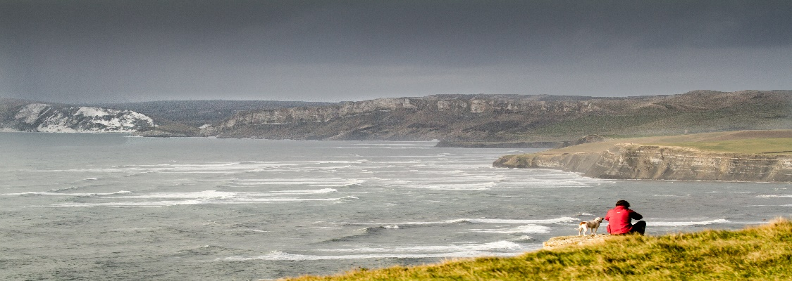

Stoborough Primary School

It has been another extremely busy year at Stoborough Primary School and I am pleased to share some of our success with you.

During the summer term we held a Literary Week and had a wonderful time when international story teller, Clive PiG, joined us! Some fantastic writing was achieved during and after his visit.

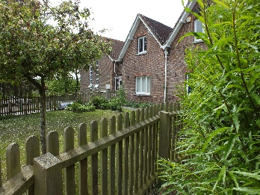
At the end of summer 2018, we were awarded our third Gold Award for Sports. This is assessed externally and annually. Stoborough School pupils love their sports and the school is committed to offering a rich and varied range of activities for our children. This now includes clubs run at breakfast, lunch and after school by professional coaches. We have also been committed to supporting those pupils who are not so active, and we now provide specific sessions to encourage enjoyment of physical exercise – this is important for overall health and well-being. We believe the children learn a range of skills including team work, striving for personal best, leadership, effective co-operation and communication and building self-esteem and confidence. We aim to be the first school in Dorset to achieve the Platinum award but need to gain a run of five Gold Awards. I am certain we can achieve this – we are very competitive at Stoborough and enjoy a challenge!

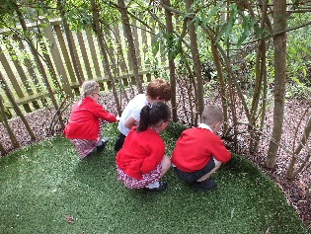
In September 2018 we had an inspection for ECO Schools Award and I am delighted to say we were awarded our third Green Flag. For those of you that have close links with the school, you will know that we have a very active ECO pupil and parent group and they spear head the varied aspects of school life connected to this. We are all committed to looking after our local environment, saving energy, reducing our carbon footprint and to increasing awareness of things such as global warming, plastic in the environment and looking after and caring for our finite planet. Children and staff are passionate about this. The children created a wonderful display linked to the book ‘The Lost Words’ which can presently be seen in the school entrance. I am delighted to say that Robert MacFarlane, the author of the book, was sent photos of some of our learning connected to this and responded by saying ‘Look at that display! Amazing! Those newts, such proud and fierce dragons of the duckweed, those curving otters …. Please send huge congratulations to the children and their teachers on this vivid, inspired creative work.’ We are now participating in a photography project linked to the book.

We continue to face many challenges as do all schools in the present educational climate but are passionate about working hard for all our pupils and aspire to achieve a well-rounded education for them. We are committed to giving the children as many different experiences as possible and to sow a variety of seeds and to nurture their growth. The children remain precious to all of us.

Deborah Corbin
Head Teacher, Stoborough Primary School

Stoborough Allotments

We are very fortunate to still have allotments available for residents in the parish. There is a total of 25 in all and, as we go to print, there is still one vacant.

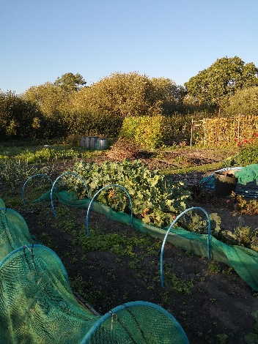
Positioned alongside Corfe Road, they are easily accessible and are allocated on a first come first served basis. Priority is given to applicants who physically reside in the Parish and who do not have allotments elsewhere and have limited facilities for growing produce. However, applications from voluntary community groups or institutions may also be considered. If you relocate out of the parish, the plot will have to be handed back to the Parish Council for a local resident on the waiting list. Should there be no local resident on the waiting list, the Parish Council may agree to allow the tenant from outside the Parish to remain on a year by year basis.
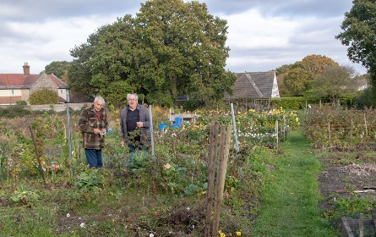

Don’t worry if you think you don’t know enough about gardening, there will be plenty of fellow allotment holders available to give you help and advice.

If you would like your name added to the list, please contact the Clerk.

----------------------------------------------------------------------------------------------------------------

Bog Lane Natural Greenspace – our own SANG

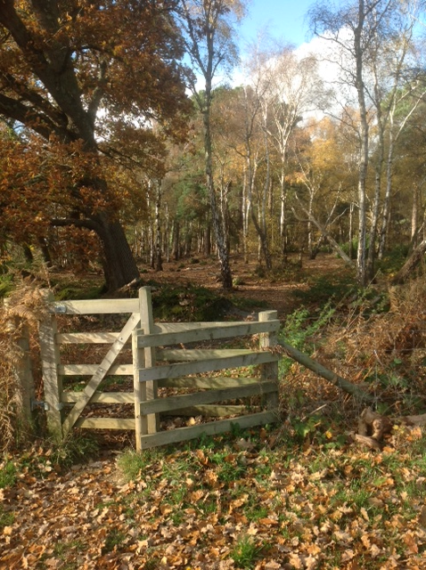
You may not know that, in our parish, we have our own SANG (Suitable Alternative Natural Greenspace). This was provided as a result of a development at Westgate, just outside our parish in Wareham, immediately opposite the Purbeck School.

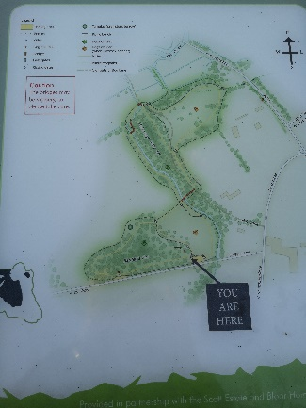
SANGs are provided for local community use as an alternative open space to allow mitigation for the potential impact of residential development, preventing an increase in visitor pressure on surrounding heathland. The effectiveness of SANGs as mitigation depends upon their location and design. In the case of our own SANG, its location has always been in question, as there is little evidence that residents from the Westgate development use it. However, it presents a wonderful opportunity for another accessible walk and is open to the public.

The Bog Lane SANG can be located a few metres along Holme Lane where you will find a small car park, with somewhat constricted access. To the immediate west of the car park is a wooded area, Bartlett’s Firs. To the north is a field, often used by cattle, and beyond that lies Stoborough Withy.

You might think that Bog Lane is a quirky name choice, but it is the name of an old track from what is now West Lane, heading north-west through the Withy Bed towards the River Frome. The area has been provided in partnership with the Scott Estate and Bloor Homes South and is managed by Savills.

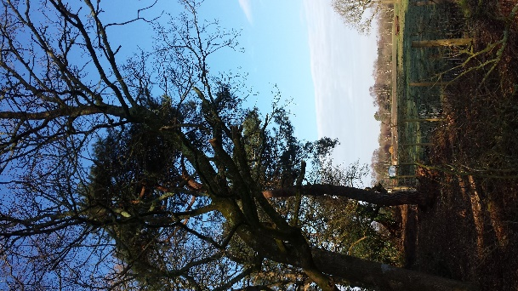
You can enjoy walking your dog, watching wildlife or having a picnic. If you do not want to walk in the field when the cattle are grazing, Bartlett’s Firs is a lovely wooded area with a circular route back to the car park. Both Bartlett’s Firs and Stoborough Withy are surrounded by fencing, which makes them cattle free.

As you walk through Bartlett’s Firs, you will notice a prehistoric barrow. This is a type of bronze age burial mound known as a ‘bowl barrow’ from its resemblance to an upturned bowl.

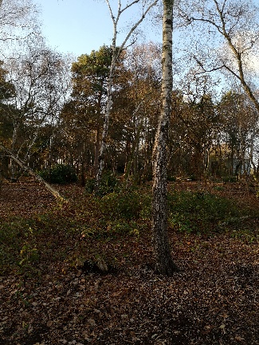
The bridges and boardwalks may be slippery, particularly in Stoborough Withy, so take care as you walk.

If you are a dog owner, you are requested to respect other visitors and keep your dog in sight, protect nesting birds by keeping to paths and using a short lead when cattle are in the field, and, of course, ‘bag it and bin it.’

Although the Parish Council has no responsibility for its upkeep, it is regularly monitored and discussed at our monthly meetings.

Although fairly small in size, the Bog Lane SANG is a relatively new and interesting local facility and, as such, is worth a visit.

Cllr Ashley Pellegrini

----------------------------------------------------------------------------------------------------------------

The Hayricks, Corfe Road

We are also very fortunate to have this wonderful, large open space in the parish, available for all residents to use. Back in 2012 the concrete path was installed so children could ride their bikes on it but also to enable the more elderly and less stable of our residents to enjoy this lovely open space.

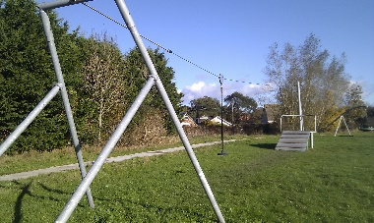
As well as the under 5s play area, we also have a few bits of play equipment for the older children and for the young at heart. The zipwire (a personal favourite), the basket swing and the bike ramps. All are the responsibility of the Parish Council and regular weekly visual checks are carried out. If you do spot anything, please feel free to contact the Clerk and report it.

Whilst we welcome dogs on the site and it is a great place for them to enjoy themselves, we would ask that owners please be mindful of other users. Not everyone is comfortable around dogs and, if you notice someone looking concerned, please keep your dog on a lead.

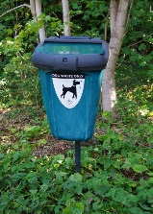
There are four bins around the Hayricks, all of which can be used for dog waste and all are emptied regularly. We would like to thank all those responsible owners who do clear up after their dog and would ask all those who don’t to please remember other users and to act responsibly. Amanda Crocker, Parish Clerk

The Arne Moors Project

A word from the Project Partners….

The Environment Agency, RSPB and Natural England are working together to adapt approximately 150 hectares of the Moors at Arne into a diverse wetland habitat.

With the sea level rising, important habitat for wildlife along the coast will be lost over the next 30 years. Where rising waters press against essential fixed sea defences, called ‘coastal squeeze’, this will mean a loss of inter-tidal features such as mudflats and salt marsh. New places for coastal wildlife will need to be created, particularly if the government is to realise its ambitious 25 year environment plan.

In Poole Harbour, the partners are working together to explore how The Moors at Arne can be converted to inter-tidal habitat to compensate for the losses.

The scheme will involve the construction of new tidal embankments further inland than the existing ones. Once in place, the land in front of the new embankments will be opened to the action of the tides and, with this, new salt marsh habitats will be created.

These new tidal embankments will be robust, and the scheme will give greater flood resilience for local people and property. The partnership will not proceed with a scheme that causes houses to flood.

Initial feasibility work is also helping the partnership and the local community to better understand local problems with surface water with the possibility, through the scheme, of reducing impacts related to this issue. The coastal change project will enable the Environment Agency and its partners to continue to protect properties around Poole Harbour from the increased risk of flooding and erosion due to climate change. It is predicted up to 10,000 local properties could be at risk within 100 years.

The partners delivering this scheme have, for over fifty years, worked to keep Purbeck a special place. This scheme is a continuation of that work and builds on many similar successful schemes elsewhere. The partnership will maximise the benefits for both local people and wildlife and we look forward to involving the community as the scheme evolves. This to date includes numerous meetings with the parish council and meetings to share the results of the surface water surveys and groundwater surveys. We have also set up a Stakeholder Liaison Group, on which the parish council has a representative.

All information on display at the public exhibition held in November is available to view on the website: https://dorsetcoast.com/groups/the-moors-at-arne-coastal-change-project/

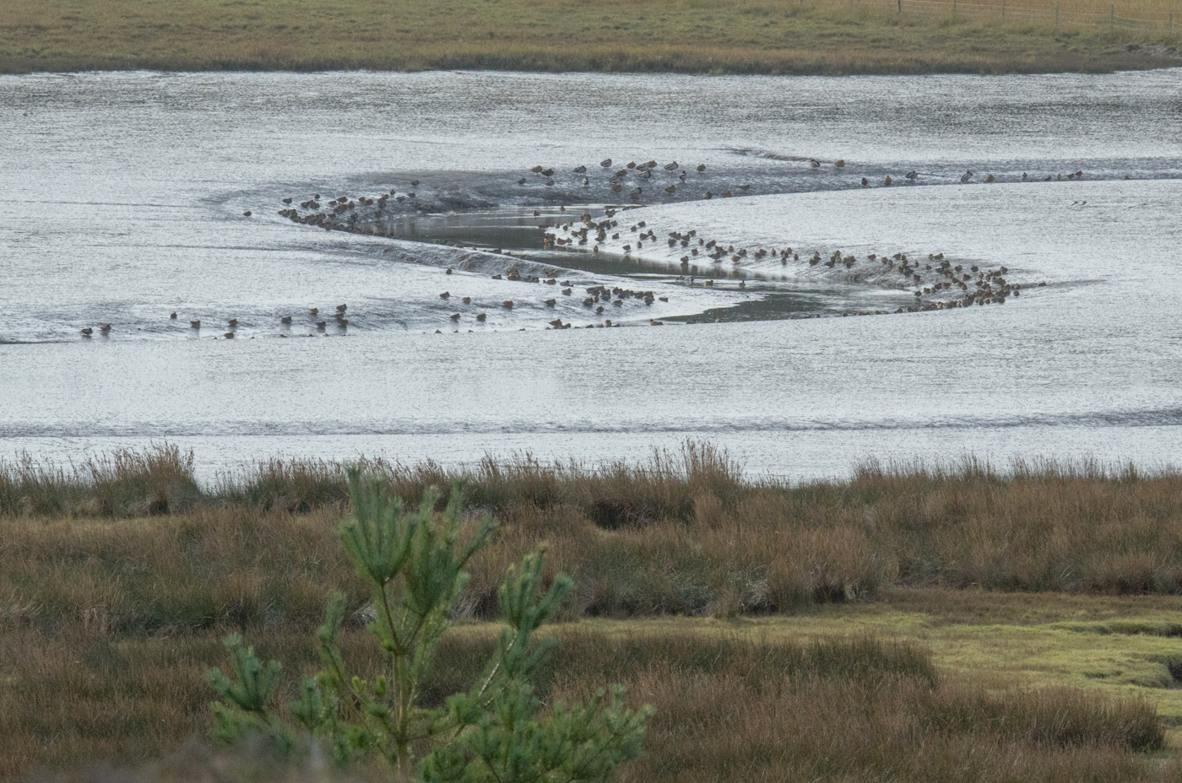

Arne Parish Council response…..

This controversial project has been included in every Parish Council discussion this year and all those meetings held at the latter end of 2017. At the Parish Council meeting held on the 15th March 2018, councillors unanimously agreed to the following proposal, which now forms the Parish Council’s policy.

We are conscious that many aspects of The Moors at Arne Coastal Management Project may change over time and, as a result, this policy may need to be amended.

Whereas:

- The Environment Agency is working with the RSPB and Natural England to explore the possibilities of building a new tidal embankment closer to Arne Road and creating gaps in the existing bank;
And
- The Environment Agency states that any proposal developed by the project will have to demonstrate no adverse impact through a combination of its basic design/and or parallel control measures;
And
- The Environment Agency states that this project will allow it and its partners to maintain defences to protect properties form flooding for the next 100 years;
And
- The Environment Agency states that it is aware that there are existing surface water drainage issues in Ridge;
And
- The Environment Agency states that it will check that its design will not ‘unduly’ impact navigation in the River Frome channel due to silting.

However:

- There is no mention of bringing the South bank from Wareham to Ridge Wharf up to the same standard as the proposed new bank or its future maintenance; this will be critically important to residents;
And
- There are major concerns about construction traffic and the routes it may take;
And
- At the moment, there is poor amenity access to the South side of the Wareham channel and, although improvements have been mooted, there is as yet no specific plan;
And
- With the existing defences no longer viable, it is not known what the final proposal will be in terms of position and routing of the new bank, its proximity to Ridge, where the gaps in the old wall will be created, what the construction technique will be and what the solution to Ridge drainage issues will be.

And so:

With so many stated performance commitments by the Environment Agency and yet so many ‘known unknowns’ listed above, Arne Parish Council, together with local residents, recognise that there is a huge risk attached to this project and, therefore, the onus is on the Environment Agency to demonstrate that the scheme will work.

But, as the existing defences are no longer viable, doing nothing is not an option either.

It is, therefore, Arne Parish Council’s policy;

- To press for a plan which keeps the new tidal embankment as far from Ridge as possible;
- To press for a plan which also safeguards the south bank from Wareham to Ridge Wharf;
- To ensure that all survey and modelling findings, interpretation and emerging options are made available to and discussed with the community in a full and timely manner and in advance of further proposals;
- Once the plan is known, to have it scrutinized by independent review prior to it going to planning to ensure it is fit for purpose;
- To hold the Environment Agency, RSPB and Natural England to their statements that the Moors at Arne Project will not be undertaken if there is any risk of flooding. This principle to apply to risks of flooding from all causes – sea level rise, surface water and confluence of river in flood and spring high tides – and to all aspects of options within the project;
- This plan to provide effective long-term protection;
- In the event of any plan proceeding, the EA will be held accountable and responsible for any future failure of the project which has any adverse effect on local residents’ properties or livelihoods.
- These policies to be under continuing review, especially once the EA’s detailed proposals are known.

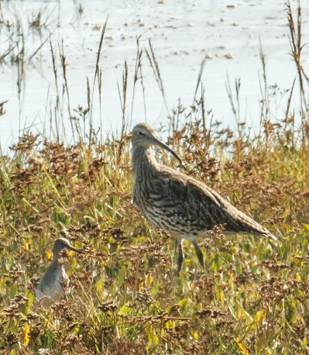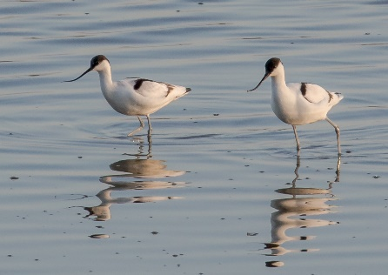

Recollections of Stoborough Fetes

A quick look at some old press cuttings and photographs prompted memories of the Stoborough of old.

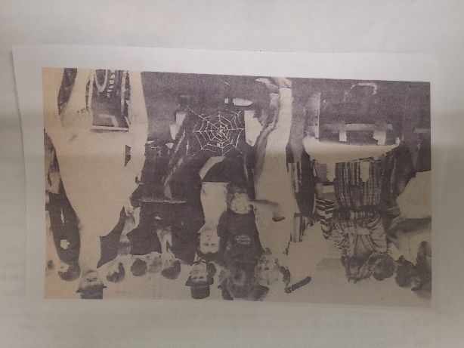
Around forty years ago, the summer fetes at Stoborough School were as popular as they are today. The fete used to be held on the same day as the Wimbledon Women’s Tennis Final and announcements about this were given periodically during the afternoon. The fetes were always popular, attended by people from far and wide.

A fancy-dress wheelbarrow race was a colourful feature of the evening’s programme. The route of the race ran from the village, up Nutcrack Lane to the crossroads, then downhill at New Road to Corfe Road and back to the school. The wheelbarrows turned up ready for action well in advance and both the wheelbarrow and competitors had to be dressed up. Competitors began with a drink at the start and this was repeated at two stops along the way. The photograph shows the somewhat macabre entry that won the competition one year and the presentation of the shield to the winner. The whereabouts of the shield has long been forgotten but perhaps someone who is reading this may be able to shed some light on its location.

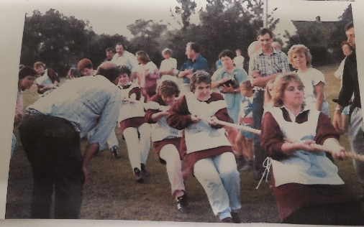
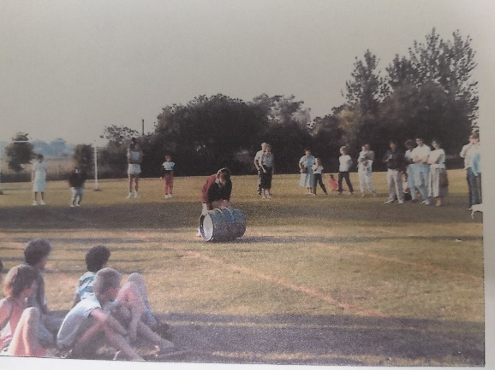
A men’s and ladies barrel race involved pushing a metal beer barrel backwards and forwards along a set course. The ladies of the parish also formed a tug-of-war team to compete against the men. With seven members and one anchor on each team, the determination of the ladies was great, but the men prevailed. The race was organised for about two or three years but, as children left the school, so did the parents and the competition stopped. A rigorous training regime was imposed for the ladies’ team by one of our own parish councillors and was carried out on the old Stoborough football field where Scott Close is now situated.

A beer tent was heavily utilised by parents and other locals and a pig was roasted at the bottom corner of the field by a group of people called the SPRATS. Does anyone recall what SPRATS stood for? It is understood that the pig was put on the spit at the Kings Arms and then carried to the school for roasting.

Stoborough School’s highly regarded fetes continue and are a hugely successful community venture.

Does anyone else have any memories or old photographs that they would be willing to have published in the next Parish Magazine? If so, please contact the Clerk on 01929 472327.

Cllr Phil Love

The Parish Council Lengthsman

This scheme has been running since April 2017 and, in many respects, has proved very successful. Having someone on hand to respond quickly to any issues that may arise around the parish can only be a good thing.

In case you haven’t already met him, this is Jamie, our Lengthsman. He has his own established company, JSR Tree Care and Garden Maintenance and is based in Swanage, having moved from Berkshire over six years ago.

The role of the Lengthsman is varied but includes:
- Maintaining the play equipment
- Keeping Rights of Way clear and passable
- Checking and maintaining stiles, walkways and fences where appropriate
- Maintaining and repairing finger posts and notice boards
- Cleaning, fixing and repairing street furniture and signs owed by the Parish Council
- Painting, maintenance and cleaning of various items including benches, dog and grit bins
- Clearing footpaths and access ways during winter conditions and distributing salt/grit
- Clearance of ditches, drains, etc
- Removal and control of weeds and other vegetation

That is just a very small list of the work he undertakes for the Parish. Be sure to say hello when you see him out and about in the Parish.

----------------------------------------------------------------------------------------------------------------

Stoborough WI meets monthly on the second Wednesday of each month from 2pm until 4pm at Stoborough Village Hall. The formal meeting lasts approximately 30 minutes and is followed by a tea break and then a speaker or activity. Visitors may attend the meeting at a charge of £3 per visit up to a maximum of 3 visits. Within Stoborough WI there are a number of smaller groups who meet regularly: skittles, walking, craft, book and kurling. Outings, coffee mornings and afternoon teas are organised throughout the year.

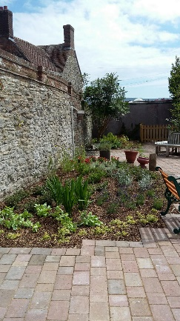
Although fundraising is not a primary aim of WI, we do hold occasional events to raise funds for the WI and some proceeds are donated to local charities. Recently we provided money for much needed chairs at Wareham Surgery and over 2016 and 2017 we raised money for a community defibrillator, which is now installed at the Kings Arms pub. For a number of years members have planted and maintained flower tubs in the Wareham Library garden.

Stoborough WI is part of the Dorset Federation of Women’s Institutes. Each year there is an Annual Meeting at the Lighthouse in Poole which members may attend. The Federation also organises outings for WI members throughout Dorset.

If you would like to come and meet us, please telephone 01929 551776.

Mrs Jill Scragg

Arne Parish Council Flood and Resilience Plan Update

The Parish Council is currently compiling a plan which will document how Arne Parish Council would respond in an emergency situation/major incident, e.g. while awaiting the assistance of statutory authorities or emergency services, or in a supporting role.

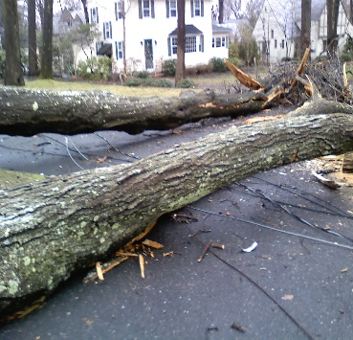
An emergency/major incident is any event or circumstance that causes disruption to the community on such a scale that the effect cannot be dealt with immediately by the emergency services or local authorities. Such emergencies/incidents include problems with essential power supplies, transport disruptions or a breakdown in communications.
This Photo by Unknown Author is licensed under CC BY-SA

The Plan will identify a Response Centre, where residents can receive up-to-date information, request assistance, provide assistance to others and, hopefully, get a cup of tea!

Arne Parish Council has already been successful in securing valuable funding from SSEB, in order to purchase essential equipment to operate a Response Centre. We extend our thanks to them.

Such an undertaking would require a communal response, and Arne Parish Council would welcome contact from volunteers who would be interested in offering their skills, transport or equipment. Ideally, the Parish Council would appreciate contact from residents who have skills in the following fields and would be prepared to assist as required:

Medicine Nursing
Caring Electrical
Telecommunications Tree Felling
Catering

and the many other skills that would make a difference.

Offers of transport, equipment and food provisions in the event of a major situation would be greatly welcomed.

Please contact the Clerk, as your assistance would be crucial in making the difference.

Flood Warnings

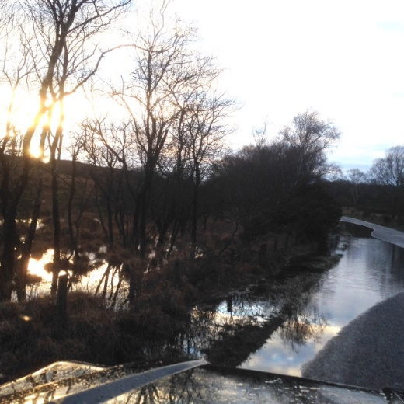
Yet another extremely wet winter.

Since April 2017, 26 flood alerts have been issued for the area and 1 flood warning in early April 2018, with a further 9 to date.

By contacting the Environment Agency on 0345 988 1188, residents can sign up to receive alerts by telephone, text or email.

If you experience any new or unusual flooding issues, please let us know, as this will assist in influencing the Flood Plan.

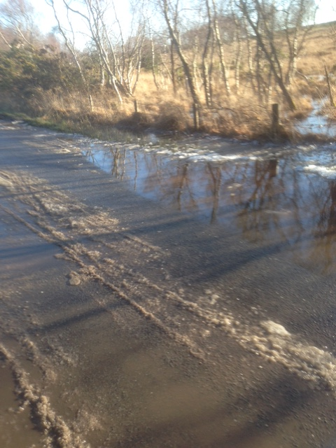
Arne Parish Council would welcome contact from any residents who would be interested in acting as Flood Wardens in their immediate vicinity. This does not involve getting wet feet, just the ability to monitor and report back to the Parish Council.

Your eyes are our ears, so the sooner that issues are reported, the sooner we can deal with them. A volunteer from each road in the parish would enable us to keep on top of issues.

Those who are happy to help in an incident, don wellies and assist in any way, are most welcome.

Residents can go online at www.dorsetforyou.gov.uk/report-a-road-problem to report any flooding/road issues, or telephone 01305 221000.

Please contact the Clerk if you feel you could offer your assistance. It would be most appreciated.
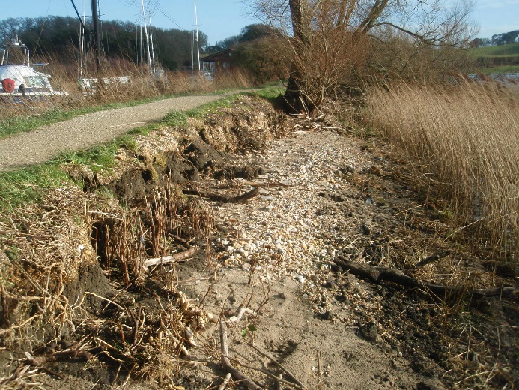
Cllr Vivienne Ward, Flood Liaison Officer

----------------------------------------------------------------------------------------------------------------

From Tortoises to Hares?

Many Ridge residents will have noticed a sudden influx of BT Openreach vans and men with surveying tools trundling around the village.

The men report that the whole of Ridge is being supplied with a state of the art ‘Ultrafast’ ‘fibre to the premises’ (FTTP) broadband system with speeds up to 300mb/sec. The work is expected to take from four to five months and, as usual, residents will have a choice of service provider and level of service. This follows several years of lobbying from Arne Parish Council and Ridge residents alike – it now looks as if this higher speed, potentially more reliable installation might have been worth the wait!

Arne Parish Council Neighbourhood Plan
Arne Parish has a unique natural environment formed by past cultural, economic, social, industrial and agricultural practices. While recognising and protecting its heritage, we seek to ensure the long-term sustainability and viability of the parish through environmental and economic measures that will develop the community and its charm, so that all its residents, young or old, continue to live in a community where they feel safe, cared for and happy.

The Neighbourhood Plan, begun in 2013 is finally approaching completion.

Between Friday 7th December 2018 and Friday 25th January 2019 the Neighbourhood Plan Steering Group will be formally consulting the community on the Draft Plan.

You can view the Plan and access a response form online at arne-parish-council.sycl.net

Copies of the Plan and feedback forms will also be available to review at the Wareham Library and the Kings Arms pub.

A formal consultation event will be held on Monday 14th January 2019 at the Stoborough Primary School between 4pm and 8pm.

Comments on the Draft Plan can be made to the Steering Group using feedback forms returned online or via the consultation session or mailed to the Clerk, c/o Rye Hill Farm, Rye Hill, Bere Regis, Wareham, BH20 7LP.

Comments should be returned by Monday 28th January 2019.

All comments will be welcome and we look forward to hearing your views.

Your Parish Councillors

Being a Parish Councillor means more than attending one meeting a month. All of your Parish Councillors work hard throughout the month, attending various liaison groups and being involved in decision-making bodies throughout the Parish and District.

Phil Love Chairman of the Parish Council
01929 551307 Council Representative on:
Phillove232@icloud.com Furzebrook Village Hall Committee
Imerys Liaison Group
Purbeck Housing Forum

Avris Wakefield-Sutton Vice Chair of the Parish Council
01929 550432 Council Representative on:
Avris.ws@purbeck1.plus.com Emergency Resilience Committee
Purbeck Housing Forum
Stoborough Village Hall Committee
Hayricks Committee
Parish Tree Warden
Wareham Relief in Need & Sickness Charity

Don Hunter Council Representative on:
01929 551587 Broadband Liaison
Hunterdon88@gmail.com Ridge Residents Association
RSPB/NT/NE Liaison
Standards Committee
Neighbourhood Plan Chair

Vivienne Ward Council Representative on:
07778 611508 Emergency Resilience Committee
vamward@hotmail.co.uk Flood Warden
RSPB/NT/NE Liaison
Hayricks Committee
Wareham Burial Joint Committee
Wytch Farm Oilfield Liaison Committee

Ashley Pellegrini Council Representative on:
01929 554110 Dorset Association of Parish & Town Councils
apcap1997@gmail.com SANG Liaison
Stoborough Primary School Liaison
Stoborough Kill Your Speed Liaison
Standards Committee
Parish Tree Warden

Richard Bessant Council Representative on:
01929 553516 Arne Moors Project
richardbessant1@gmail.com Imerys Liaison Group
Imerys Corfe River Project
Purbeck Transport Action Group
Parish Transport Representative
SID Co-ordinator
Wareham Burial Joint Committee
Wytch Farm Oilfield

Shelley Cranshaw Council Representative on:
01929 555209 RSPB/NT/NE Liaison
shelleycranshaw@gmail.com SID Co-ordinator
Parish Tree Warden
Wareham & District Development Trust
Wytch Farm Oilfield Liaison Committee

Ian Church Council Representative on:
01929 553496 Rights of Way Liaison Officer
Ianchurch45@gmail.com Swanage Rail Transport Liaison

As you can see, there is a lot more to being a councillor than you may have thought. As well as the above roles, all Parish Councillors are instrumental in setting the Precept for the coming year and they are members of the Neighbourhood Plan Steering Group.

----------------------------------------------------------------------------------------------------------------

PARISH COUNCIL ELECTIONS

In May 2019, all the councillors must stand down and seek re-election. Several may not stand again which means there will be vacancies on the Parish Council.

If you think you have what it takes to be a Parish Councillor, then perhaps you would like to put your name forward. You must meet a few, simple criteria first –

- You must be over 18 years old

- Be a member of the Commonwealth or a citizen of a member state of the European Union

- Be an elector of the parish

In addition, you will be qualified if either, during the whole of the twelve months before the day on which you are nominated as a candidate, or the day of the election, have resided in the parish or within 3 miles of it or occupied as owner or tenant any land or premises in the parish or had your principal or only place of work there.

The most important requirement is that you must want to get involved in shaping the future of your community and be willing to give a few hours of your time every month to making it happen.

If you think you can do this, please submit your name and contact details to the Clerk or to Purbeck District Council Democratic & Electoral Services on 01929 557221.

If you have any observations or comments you would like to make, or if you have anything you would like to include in the next Newsletter, please contact the Clerk, Amanda Crocker, on 01929 472327 or email arneparishcouncil@gmail.com

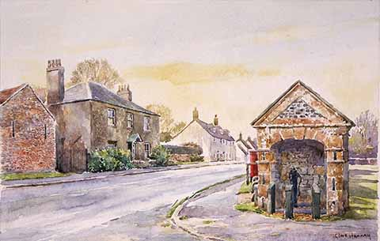

December 2018

